RIGVA
Construction Equipment Insurance
Software Project Technical Report
Evidence-based analysis of the supplied source, schema and domain material
Item | Detail
Project name | RIGVA Construction Equipment Insurance
Document type | Software project technical report (condensed)
Version | Draft 1.0
Preparation date | 12 October 2026
Author | [Author name: to be provided]
Institution or organisation | [Institution name: to be provided]
Approval | [Not provided]
Evidence basis | Supplied backend Java files, frontend source dump, MySQL creation script and domain document only. No build, runtime, test or coverage output was supplied.

Contents
1 Abstract and Project Overview 3
2 Technology Stack and Project Structure 5
3 System Architecture and Microservices 6
4 Database Design 8
5 UML and Diagram Deliverables 9
6 User Journey and Workflow Analysis 23
7 Functional Requirements and Business Rules 24
8 API Documentation 26
9 Security, Authentication, JWT and RBAC 27
10 Validation, DTOs and Exception Handling 29
11 Testing and Code Coverage 30
12 Logging and Monitoring 31
13 Assumptions, Limitations and Future Enhancements 32
14 Conclusion 33
Appendix A Endpoint Catalogue 34
Appendix B Discrepancy and Gap Register 37
Appendix C Test File Inventory 38
Appendix D Frontend API Clients, Guards and Storage 39

1 Abstract and Project Overview

1.1 Abstract
RIGVA Construction Equipment Insurance is a multi-service system for managing insurance on machinery used by construction, mining and infrastructure companies. A customer can insure many machines under one master policy. The system covers the full lifecycle: company and equipment registration, quotation and underwriting, policy issuance, mid-term endorsements, first notice of loss (FNOL), claim assessment and settlement, billing, and renewal.
The supplied material consists of 432 backend Java files (400 main, 32 test) in seven modules, 102 REST handlers, 462 Angular frontend files, and a MySQL script defining 17 tables across five service databases. This report documents what that code and schema show. It does not report any test execution, runtime behaviour, or measured coverage, because none was supplied.
Keywords: construction equipment insurance; master policy; underwriting; endorsement; claim settlement; microservices; Spring WebFlux; Spring Data R2DBC; JWT; Angular; MySQL.

1.2 Background, Motivation and Problem Statement
According to the domain document, insuring each machine separately is costly to administer. A master policy lists each piece of equipment with its serial number, value, sum insured, project site, coverage and deductible. The domain document describes customers and contractors, underwriters, adjusters, surveyors, examiners and operators, and sets out risk scoring, underwriting decisions, premium calculation, claim settlement and renewal rules. The problem the system addresses is consistent management of these rules across the policy lifecycle.

1.3 Objectives and Scope
The domain document states the objectives. The code supports them through five business services behind an API gateway. The scope of the supplied code is: customer onboarding and master data (Auth, Equipment Management), quotation, underwriting, policy and endorsement handling (Underwriting and Policy), claims handling (Claims), invoicing, payments and notifications (Billing and Notification), and a single-page Angular client. Service discovery is provided by a Eureka server module.

1.4 User Groups and Roles
The role enumeration in the Auth service defines five roles. Table 1 lists them with the main backend capabilities each role is permitted to call, as annotated in the controllers.
Table 1. User roles and principal permitted capabilities
Role | Principal capabilities in code (controller annotations) | Evidence
CUSTOMER | Register company, manage equipment, operators and project sites, create quotes, submit FNOL, create endorsement requests, view own policies and claims, make customer quote decisions | UserRole enum; CompanyController, EquipmentController, QuoteController, ClaimController
UNDERWRITER | Review queue and decisions for quotes and endorsements, risk assessment | UnderwritingController, RiskAssessmentController, EndorsementController
POLICY_OFFICER | Create and issue policies from quotes, issue endorsements, create invoices, refunds, renewal queue | PolicyController, PolicyIssuanceController, InvoiceController
CLAIMS_OFFICER | Claim decision, assessment, eligibility review, settlement calculation, payment request, claim closure | ClaimDecisionController, ClaimAssessmentController, ClaimSettlementController
ADMIN | Administrative actions in many controllers: user administration, company approval and status, settlement authority review, and most staff operations | AdminUserController, CompanyController, SettlementAuthorityReviewController

1.5 Key Capabilities Evidenced in Code
The following capabilities are visible in the supplied code: self-registration of customer accounts with BCrypt password hashing; JWT issue and refresh; administrator management of users and roles; company registration with an administrator status workflow; master records for equipment, operators, project sites and maintenance; equipment assignment with an overlap check; quote configuration, submission and risk-score calculation; premium calculation with a minimum floor; policy issuance and endorsement workflows; claim registration, eligibility review, assessment, classification, settlement and authority review; invoices, payments with an idempotency key, refunds and overdue processing; and in-app notifications.

1.6 Technical Approach and Architecture Summary
The backend is a set of Spring applications using a reactive stack (Mono and Flux return types, WebFlux security, Spring Data R2DBC repositories). Each business service owns its schema. Services call one another over HTTP using WebClient. Access tokens are HS256 JWTs issued by the Auth service and validated by every service. The frontend is an Angular application that loads its runtime configuration from a JSON file. Chapter 3 gives the architecture in detail.

1.7 Intended Outcomes and Demonstrated Evidence
Table 2 separates what the system is intended to achieve, as stated in the domain document, from what the supplied evidence shows. No outcome is marked as demonstrated at runtime, because the code was not built or executed.
Table 2. Intended outcomes compared with supplied evidence
Intended outcome (domain document) | Evidence in supplied material | Status
Single master policy covering many machines | policies and policy_equipment tables; PolicyEquipment entity | Implemented in code; not executed
Risk-based quotation and premium | RiskCalculationRule, PremiumCalculationRule, risk_assessments table | Implemented; band boundaries inconsistent with domain (D-001)
Strict claim settlement formula | SettlementCalculationRule matches the domain formula | Implemented; not executed
Configurable total-loss threshold | claims.assessment.total-loss-threshold-percentage (default 75.00) | Implemented; configuration file not supplied
Endorsement premium pro-rated by days | No day-count logic found | Missing (D-007)
Secure role-based access | Gateway and per-service security configuration, @PreAuthorize annotations | Partly implemented; ownership and token-type gaps (Chapter 9)
Renewal review | RenewalController and RenewalService present | Partly verified; rules not reviewed line by line
Automated test suite | 228 @Test annotations; mostly in Auth | Present; not executed; coverage unavailable

2 Technology Stack and Project Structure

2.1 Technology Inventory
Table 3 lists the technologies found in the supplied source, with the evidence for each. Versions are not stated, because no build file (pom.xml, build.gradle), package.json or application configuration was supplied. Dependencies that are common for this stack but not evidenced in the code are not listed.
Table 3. Technology inventory and evidence
Technology | Role in the system | Evidence in supplied code | Limitation
Java with Spring Boot | Backend runtime and application framework | @SpringBootApplication classes in each module | Java and Boot versions not determinable
Spring WebFlux and Spring Security (reactive) | Reactive HTTP handling and security filter chains | Mono and Flux return types; ServerHttpSecurity; SecurityWebFilterChain beans | Version not determinable
Spring Data R2DBC | Persistence through ReactiveCrudRepository and relational mapping | 18 entities annotated @Table and @Id; 18 ReactiveCrudRepository references; no JPA or Hibernate imports | No R2DBC driver or connection configuration supplied
MySQL 8 | Relational storage, five service databases | SQL script header (MySQL 8+), utf8mb4 schemas, InnoDB tables | Schema is the only database artifact supplied
Spring Security OAuth2 resource server with Nimbus | JWT validation (HS256) at the gateway and in each service | ReactiveJwtDecoder beans; NimbusReactiveJwtDecoder; ImmutableSecret signing in Auth | Signing key source not visible
Spring Cloud Netflix Eureka | Service registry | @EnableEurekaServer in the EurekaServer module | Eureka client configuration not supplied
Spring Cloud LoadBalancer | Client-side load balancing for named services | @LoadBalanced WebClient builders in Auth, Billing, Claims and Underwriting | Mixed with hard-coded host names (D-017)
WebClient | Inter-service HTTP calls | 18 files reference WebClient across the five business modules | No timeouts or retry operators found
Swagger / OpenAPI annotations | API documentation metadata | io.swagger.v3 annotations in 45 files; OpenApiConfiguration in five modules | No generated OpenAPI document supplied
Jakarta Bean Validation | Request DTO validation | @Valid on 30 files; @NotBlank, @Size, @Email on DTO records | Validation library version unknown
Lombok | Boilerplate reduction, @Slf4j logging | @Slf4j, @RequiredArgsConstructor in several classes | Lombok configuration not supplied
SLF4J logging | Application logging | log.info, log.warn, log.error statements | Log configuration not supplied (Chapter 12)
JUnit 5 and Mockito | Unit tests | @ExtendWith(MockitoExtension.class); @Test annotations | No test reports supplied
Angular with signals and state facades | Single-page frontend | app.config.ts, provideRouter-style routes, signal() in AppConfigService, state/*/facade classes | No package.json; Angular version not determinable; NgRx not confirmed

2.2 Backend Module Structure
The backend is split into seven modules, each a separate Spring application with its own package root under org.example. Table 4 summarises each module. Counts come from the supplied files; the main-source and test-source counts are both shown.
Table 4. Backend module inventory
Module | Package root | Main and test files | Controllers | Entities | Test classes
API Gateway | org.example.api_gateway | 14 (main and test) | 0 | 0 | 6
Eureka Server | org.example.eurekaserver | 2 | 0 | 0 | 1
Auth | org.example.auth | 62 (incl. 21 test) | 13 | 1 (User) | 21
Equipment Management Service | org.example.equipment_management_service | 88 | 23 | 6 | 1
Underwriting and Policy Service | org.example.underwriting_and_policy_service | 102 | 29 | 5 | 1
Claims Service | org.example.claims_service | 88 | 15 | 3 | 1
Billing and Notification Service | org.example.billing_and_notification_service | 76 | 22 | 3 | 1

The 102 handlers in the Auth, Equipment, Underwriting, Claims and Billing modules are the full REST surface supplied. The gateway defines no controllers; its routing is expected to come from configuration that was not supplied (D-016).

2.3 Frontend Structure
The frontend has 462 TypeScript, HTML, and CSS files under src/app, with the largest share in features (205 files), core (133), and state (101). The core folder holds configuration, API clients, authentication services and guards, and the models that mirror backend DTOs. The state folder holds facade-style state (for example state/auth/auth.facade) for authentication and other areas. All 962 relative imports in the frontend resolve to files inside the supplied dump, so the frontend source appears complete apart from the runtime configuration file.

2.4 Configuration Approach
No backend configuration file (application.yml or application.properties) or gateway route definition was supplied. The Java code reads the following properties, and their values are not visible: security.jwt.secret, security.jwt.issuer, security.jwt.access-token-expiration, security.jwt.refresh-token-expiration, clients.auth-service.base-url, insurance.premium.base-rate, insurance.premium.minimum-premium, and application.correlation.header-name (default X-Correlation-ID). Two properties have code defaults: claims.settlement.authority-review-threshold (1000000.00) and claims.assessment.total-loss-threshold-percentage (75.00). The frontend reads all of its endpoint paths and settings from a JSON document located by the RUNTIME_CONFIG_URL injection token. That document was not supplied. Secret values are not reproduced anywhere in this report.

3 System Architecture and Microservices

3.1 Architecture Classification
The system is a microservices architecture. The evidence is: separate deployable Spring applications with their own packages; a dedicated database per business service in the SQL script; an API gateway module; a Eureka registry module; and service-to-service HTTP calls between modules. It is not a modular monolith, because the services do not share a database. The SQL script states that cross-database foreign keys are intentionally not used.

3.2 Components and Responsibilities
Table 5. Components, responsibilities and data stores
Component | Responsibility (from code) | Data store
Angular frontend (RIGVA) | Role-aware UI for customers, underwriters, policy officers, claims officers and administrators | None (calls backend)
API Gateway | Single entry point; CORS; correlation ID; JWT validation; converts the role claim to ROLE_ authorities; path-level policy (/internal/ denied, /api/v1/admin/ ADMIN only, /api/v1/** authenticated) | None
Eureka Server | Service registry | None
Auth Service | Registration, login, JWT issue and refresh, password change, administrator user management, company linking | construction_insurance_auth (users)
Equipment Management Service | Companies, equipment, operators, project sites, maintenance records, equipment assignments; internal validation endpoints | construction_insurance_equipment (6 tables)
Underwriting and Policy Service | Quotes, risk assessment, premium calculation, underwriting decisions, policies, policy equipment, endorsements, renewals | construction_insurance_underwriting (5 tables)
Claims Service | FNOL, evidence, eligibility review, assessment, loss classification, settlement, authority review, claim payment request, closure | construction_insurance_claims (3 tables)
Billing and Notification Service | Invoices, payments with idempotency key, refunds, overdue processing, notifications | construction_insurance_billing (2 tables; notifications table absent, D-003)

3.3 Inter-Service Communication
Services communicate by synchronous HTTP using WebClient. Documented calls in the code include: Claims calling Equipment Management for company and equipment validation, Underwriting and Policy for policy validation, and Billing and Notification for claim payments and notifications; Underwriting calling Billing for invoice creation and payment status, and Equipment Management for company and equipment validation; and Auth calling the notification service. Internal endpoints use the /internal/v1 path prefix. The clients are not consistent in how they locate services. Most clients use configured base URLs. The notification clients in Auth, Claims, Equipment and Underwriting, however, use the constant http://billing-notification-service/internal/v1/notifications, which hard-codes the host name (D-017). No asynchronous messaging, message broker, or event bus is present in the supplied code.

3.4 Data Ownership
Each service owns the tables of its database. Cross-service references are stored as plain identifiers without database foreign keys. Examples include companies.user_id referring to a user in the Auth service, quotes.company_id referring to a company in the Equipment service, and claims.policy_id referring to a policy in the Underwriting service. This is the design the SQL script documents; it means referential integrity across services is enforced by application code only.

3.5 Request Lifecycle
A protected request from the Angular client carries a bearer token. The gateway validates the signature, issuer and expiry, maps the role claim to a single ROLE_ authority, and applies path rules. The request is then forwarded to the target service, which validates the token again, evaluates class-level and method-level @PreAuthorize rules, executes the controller method, calls the service layer, and uses repositories to read or write its own tables. The response is returned through the gateway. The forwarding step itself cannot be confirmed because the routing configuration was not supplied.

3.6 Failure Handling
Each business service has a GlobalExceptionHandler (the gateway has GatewayExceptionHandler), which maps domain exceptions to HTTP responses. Inter-service clients use onErrorResume in several places. The supplied code contains no Retry, CircuitBreaker or request-timeout operators, so downstream failures are not retried or isolated by a resilience library. Chapter 10 describes the exception model.

3.7 Deployment
Deployment is not evidenced. No Dockerfile, Compose file, Kubernetes manifest or CI pipeline was supplied. The use of service host names such as billing-notification-service suggests container or cluster DNS naming, but this is an inference only and is recorded as unverified (A-007).

4 Database Design

4.1 Schemas
The SQL script creates five databases: construction_insurance_auth, construction_insurance_equipment, construction_insurance_underwriting, construction_insurance_claims and construction_insurance_billing. All tables use the InnoDB engine, utf8mb4 character set and utf8mb4_unicode_ci collation. Each service database is used only by its service, as described in Section 3.4. Figures 8 to 10 show the relationships.

4.2 Data Dictionary Summary
Table 6 lists the 17 tables. Column counts come from the CREATE TABLE statements. The mapped column count is the number of columns that appear in the corresponding Java entity, so a difference shows a mismatch between code and schema.
Table 6. Table inventory, column counts and entity mapping
Database | Table | SQL columns | Mapped in entity | Primary key and main foreign keys
auth | users | 11 | 12 (includes must_change_password, absent from SQL; D-002) | user_id; unique email
equipment | companies | 17 | 17 | company_id; unique registration_number, tax_number; user_id is a logical reference
equipment | equipment | 18 | 18 | equipment_id; FK company_id; unique serial_number
equipment | operators | 13 | 13 | operator_id; FK company_id; unique (company_id, employee_number)
equipment | project_sites | 15 | 15 | site_id; FK company_id; unique (company_id, site_name)
equipment | maintenance_records | 10 | 10 | maintenance_id; FK equipment_id
equipment | equipment_assignments | 9 | 9 | assignment_id; FK equipment_id, operator_id, site_id
underwriting | quotes | 19 | 19 | quote_id; unique quote_number; source_policy_id FK added by ALTER
underwriting | risk_assessments | 16 | 16 | assessment_id; FK quote_id; unique (quote_id, context, version)
underwriting | policies | 15 | 15 | policy_id; unique policy_number (nullable), source_quote_id; self FK previous_policy_id
underwriting | policy_equipment | 17 | 17 | policy_equipment_id; FK policy_id; unique (policy_id, equipment_id)
underwriting | endorsements | 15 | 15 | endorsement_id; FK policy_id; unique endorsement_number
claims | claims | 17 | 17 | claim_id; unique claim_number; policy, company, equipment are logical references
claims | claim_assessments | 22 | 22 | assessment_id; unique claim_id; FK claim_id
claims | claim_settlements | 15 | 15 | settlement_id; unique claim_id; FK claim_id
billing | invoices | 13 | 13 | invoice_id; unique invoice_number; unique (reference_id, reference_type, invoice_type)
billing | payments | 15 | 13 (D-004) | payment_id; unique idempotency_key and transaction_reference
billing | notifications | absent | 14 mapped fields (D-003) | No DDL in script

4.3 Keys, Constraints and Indexes
The script defines 15 foreign keys, all within a single database, 20 unique constraints, 39 CHECK constraints and 64 named indexes. Foreign keys cover the equipment, operator and site hierarchy under companies, the maintenance and assignment links under equipment, the quote-to-policy-to-endorsement chain, and the claim assessment and settlement links under claims. Money columns use DECIMAL(15,2). Dates use DATE, DATETIME and TIMESTAMP as appropriate. Thirteen columns are JSON, used for snapshots and variable structures such as operator authorized equipment types, quote equipment and coverage snapshots, policy coverage schedules, endorsement change details and conditions, claim evidence metadata, and invoice charge breakdowns.
The policy_equipment table stores snapshot columns (name, type, serial number, ownership, market and replacement values) copied at policy time. This keeps issued policies stable when master equipment records later change, which is a sound design choice for insurance records. The version columns used for optimistic locking exist in the Claims, Equipment and Underwriting schemas and are referenced by @Version in those modules.

4.4 Business Integrity Rules Enforced by the Database
The database enforces several rules directly: policy and quote end dates after start dates; project-site end date not before start date; maintenance next-due date not before maintenance date; operating hours non-negative; risk scores between 0 and 100; invoice amount paid between zero and the invoice amount; payment amount positive; equipment values positive and manufacturing year at or after 1900; and one claim assessment and one settlement per claim. The script states that assignment date overlap cannot be expressed as a unique constraint and must be enforced in the service. The Equipment service does perform this check through a count of overlapping assignments before saving.

4.5 Schema Limitations
Status and role columns are VARCHAR fields without CHECK constraints or enumerations in the schema (for example users.role and users.account_status). Their allowed values are enforced only by application enums. The script creates no foreign keys across databases, so references such as claims.policy_id cannot be checked by the database. The users table has no column for the must-change-password flag that the code uses (D-002), and the payments table holds recipient fields that the code does not map (D-004). No migration history was supplied, so the script is treated as the complete schema for this report (A-002).

5 UML and Diagram Deliverables
Eighteen figures cover the diagram types required by the master specification. Each is drawn from the supplied code, schema or domain document, and its caption states the evidence base and any gaps. Editable sources (Graphviz DOT for structural diagrams, Mermaid for behavioural diagrams) are supplied in diagram_sources.zip.

5.1 Architecture, components and use cases
Figures 1 and 2 show the components and frontend. Figures 3 and 4 give the use cases by role. Figures 5 to 7 show the domain and security classes.
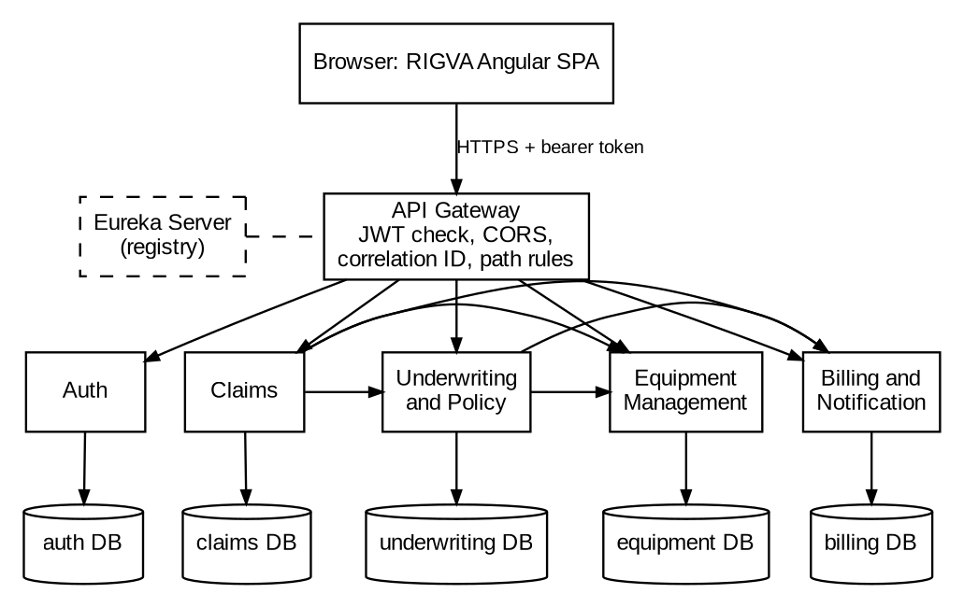
Figure 1. System context and backend components
Solid arrows are inter-service HTTP calls evidenced by WebClient clients. Dashed lines are the Eureka registry and the gateway registration, whose configuration was not supplied. The gateway-to-service arrows show the path policy in the gateway security configuration; the routes themselves are not in the supplied material. Source: fig01_system_context.dot.
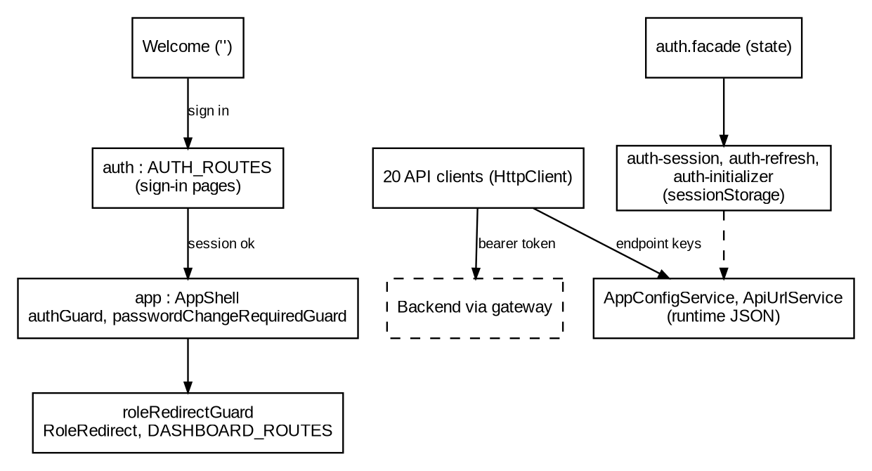
Figure 2. Frontend components and navigation
Routing is taken from app.routes.ts. Paths under app are protected by authGuard and the password-change guards, and the role redirect selects the dashboard for the signed-in role. The dashboard child routes were not enumerated in the supplied material. Source: fig02_frontend_components.dot.
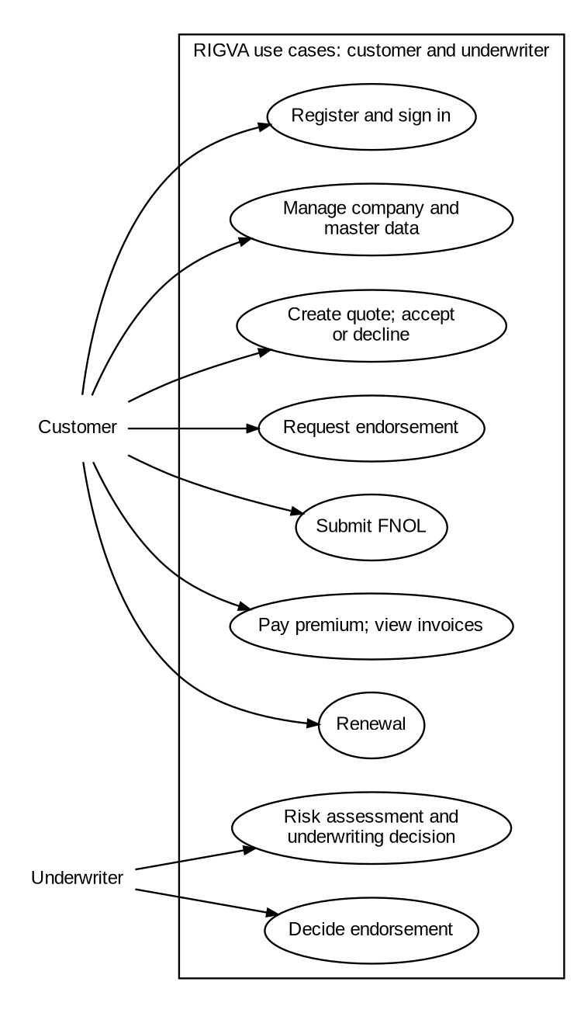
Figure 3. Use cases: customer and underwriter
Use cases are grouped from the endpoints in Table 8 and the role annotations in Table 1. Some cases, such as renewal and endorsement decisions, are shared by two roles. The diagram shows what each role may call, not how the workflow is sequenced. Source: fig03a_use_cases_customer_underwriter.dot.
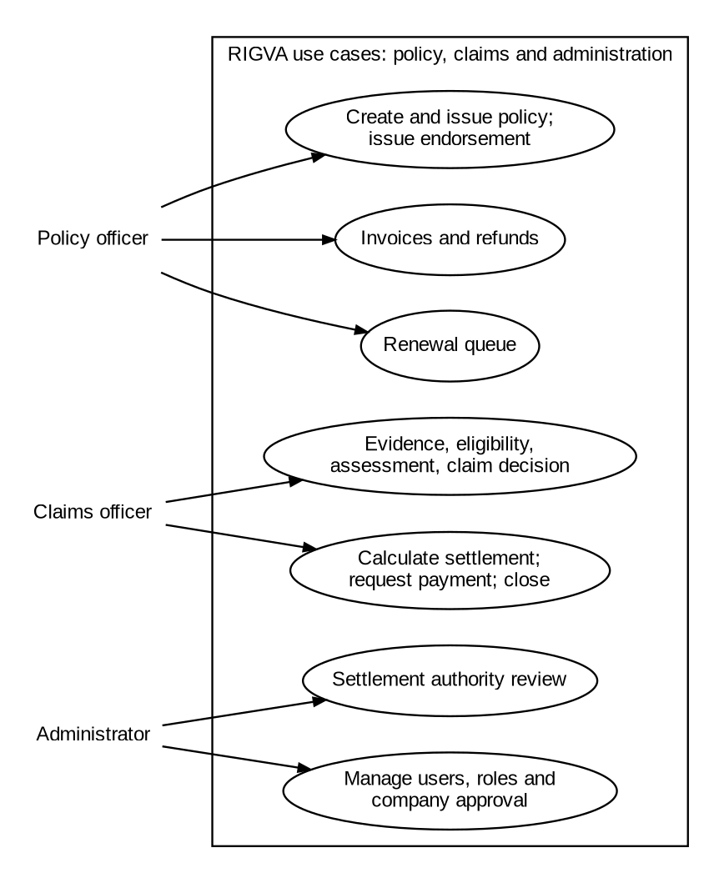
Figure 4. Use cases: policy officer, claims officer and administrator
Continues Figure 3. Policy officer, claims officer and administrator permissions follow the role annotations in the Underwriting, Claims, Billing and Auth controllers. Source: fig03b_use_cases_staff.dot.
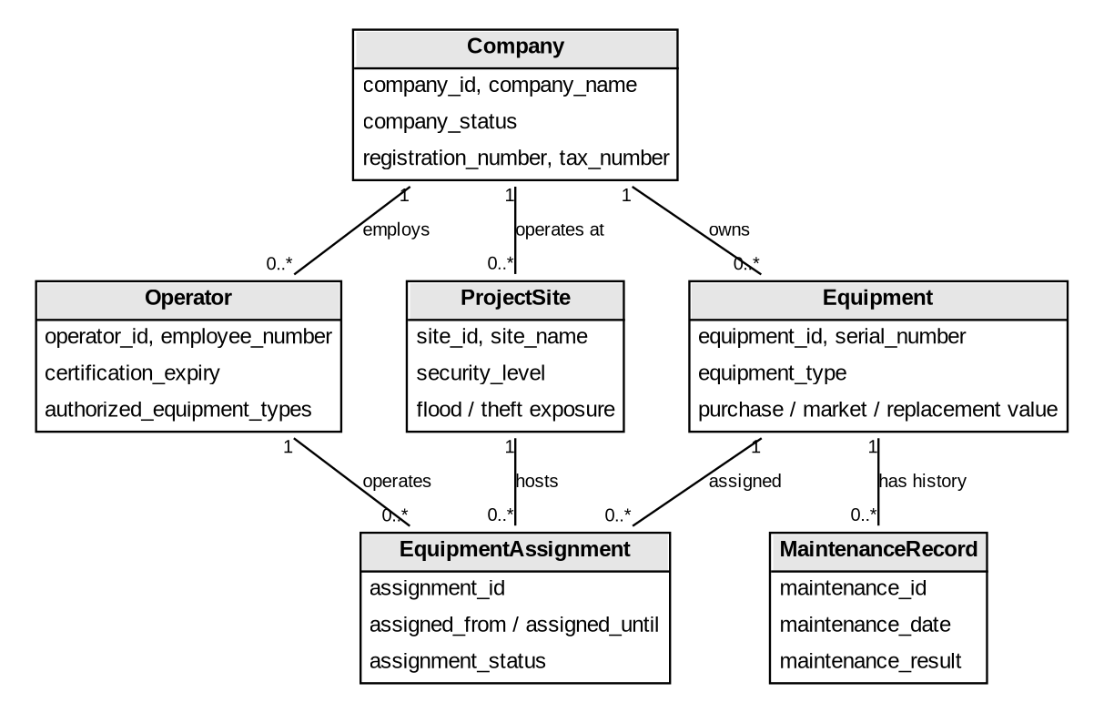
Figure 5. Domain classes: equipment operations
Multiplicities come from the foreign keys in the SQL script. Attribute lists are abbreviated; the full column sets are in Table 6 and Figures 8 to 10. Source: fig04a_classes_operations.dot.
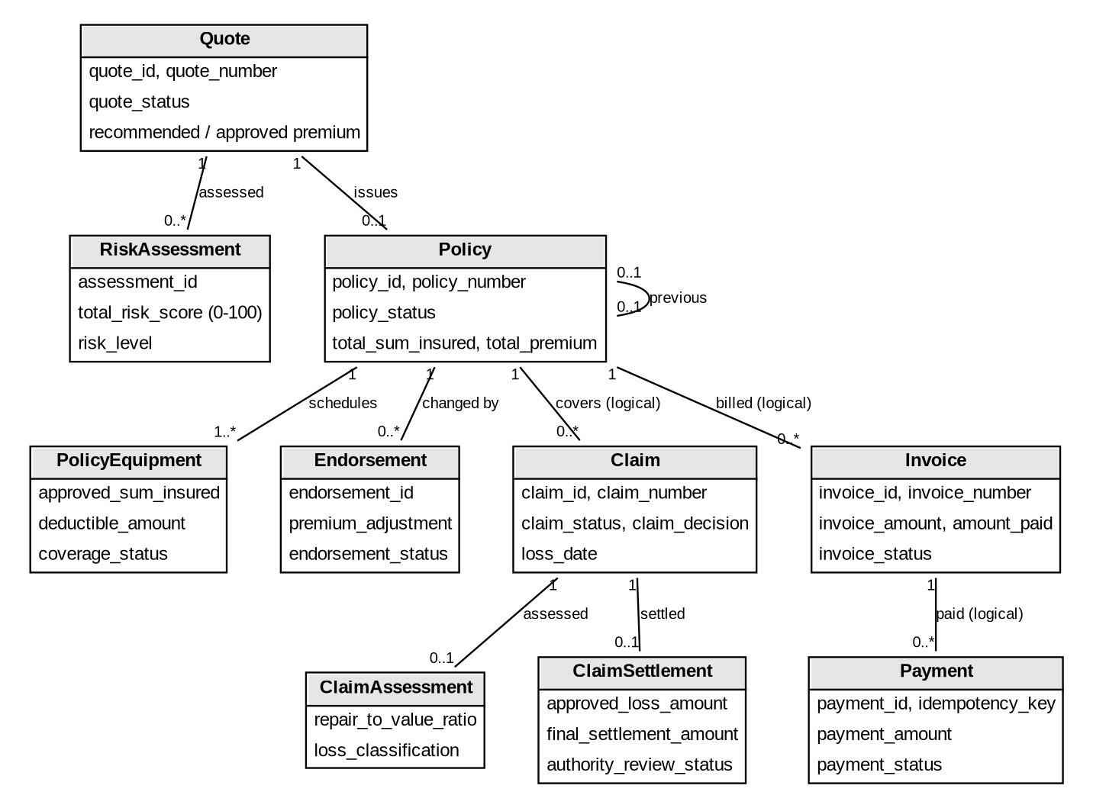
Figure 6. Domain classes: underwriting, claims and billing
Quote to policy is one to zero-or-one, enforced by the unique source_quote_id. Relations from claims and invoices to policies and payments are logical references across databases, so they are not foreign keys and are shown as logical. Source: fig04b_classes_underwriting_claims.dot.
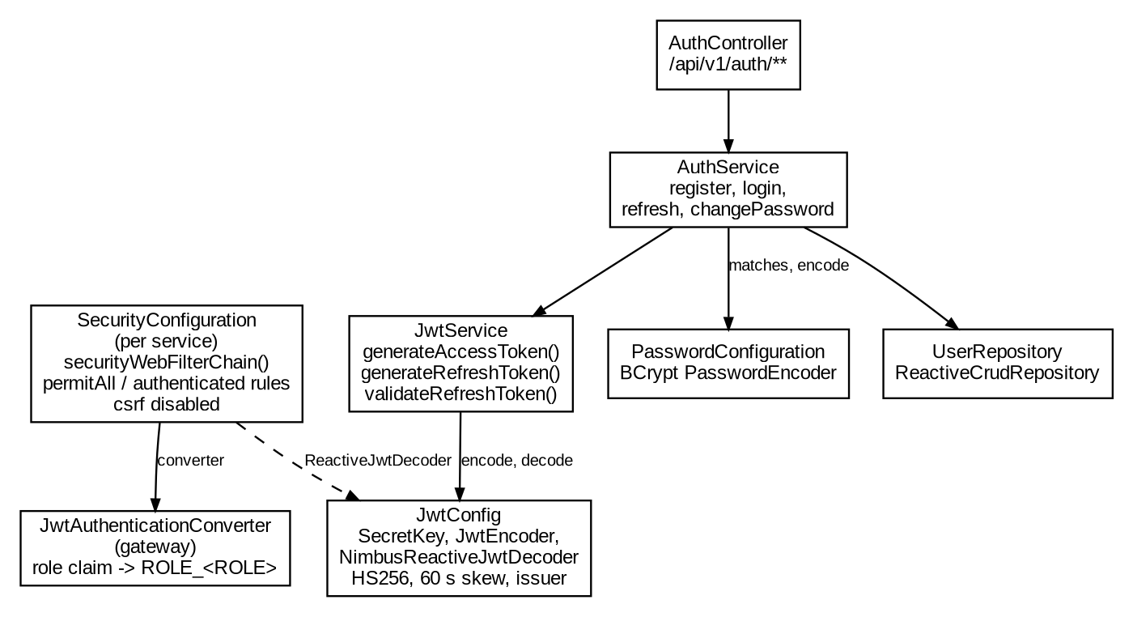
Figure 7. Focused security classes
Shows the path from login to token signing (AuthController, AuthService, JwtService, JwtConfig) and from a presented token to an authority (SecurityConfiguration and the gateway converter). Members are abbreviated. Source: fig05_security_classes.dot.

5.2 Entity relationships
The relationship diagrams are split by schema. They show key columns, keys and foreign keys. Dashed boxes are external to the schema or exist only in code.
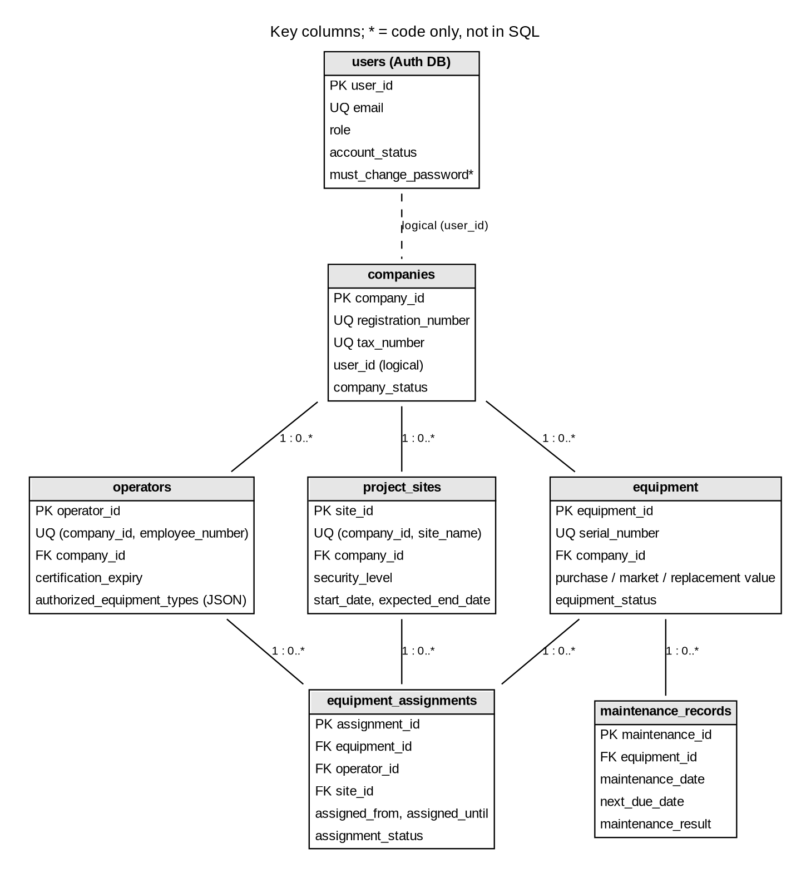
Figure 8. ER: Auth and Equipment Management schemas
The users table is in the Auth database. companies.user_id is a logical reference to it. The must_change_password column is used by the code but absent from the SQL (D-002). Source: fig06_er_auth_equipment.dot.
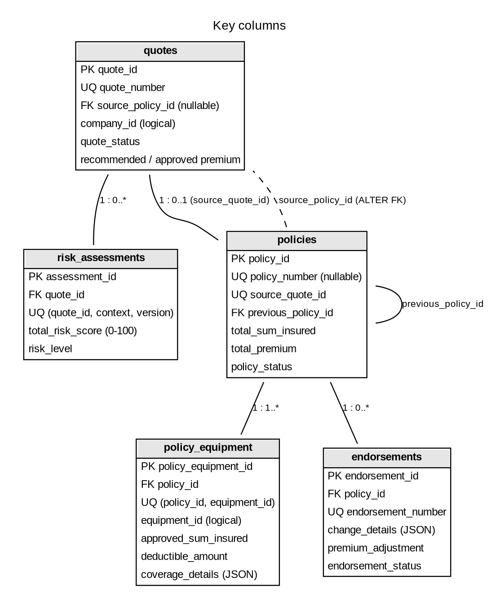
Figure 9. ER: Underwriting and Policy schema
The quotes to policies relation is one to zero-or-one through source_quote_id. quotes.source_policy_id is a later ALTER TABLE foreign key, so the relation is bidirectional but nullable at creation. Source: fig07_er_underwriting.dot.
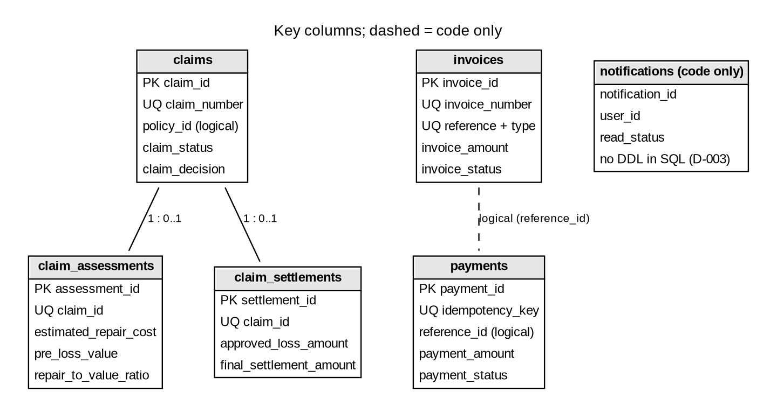
Figure 10. ER: Claims and Billing schemas
Claim assessments and settlements are one-to-one with claims. Payments reference invoices logically, through reference_id and reference_type. The notifications table has no DDL in the SQL (D-003), and recipient fields in payments are not mapped (D-004). Source: fig08_er_claims_billing.dot.

5.3 Authentication, authorization and workflow sequences
Figures 11 and 12 cover authentication and authorization. Figures 13 and 14 show the two principal workflows.
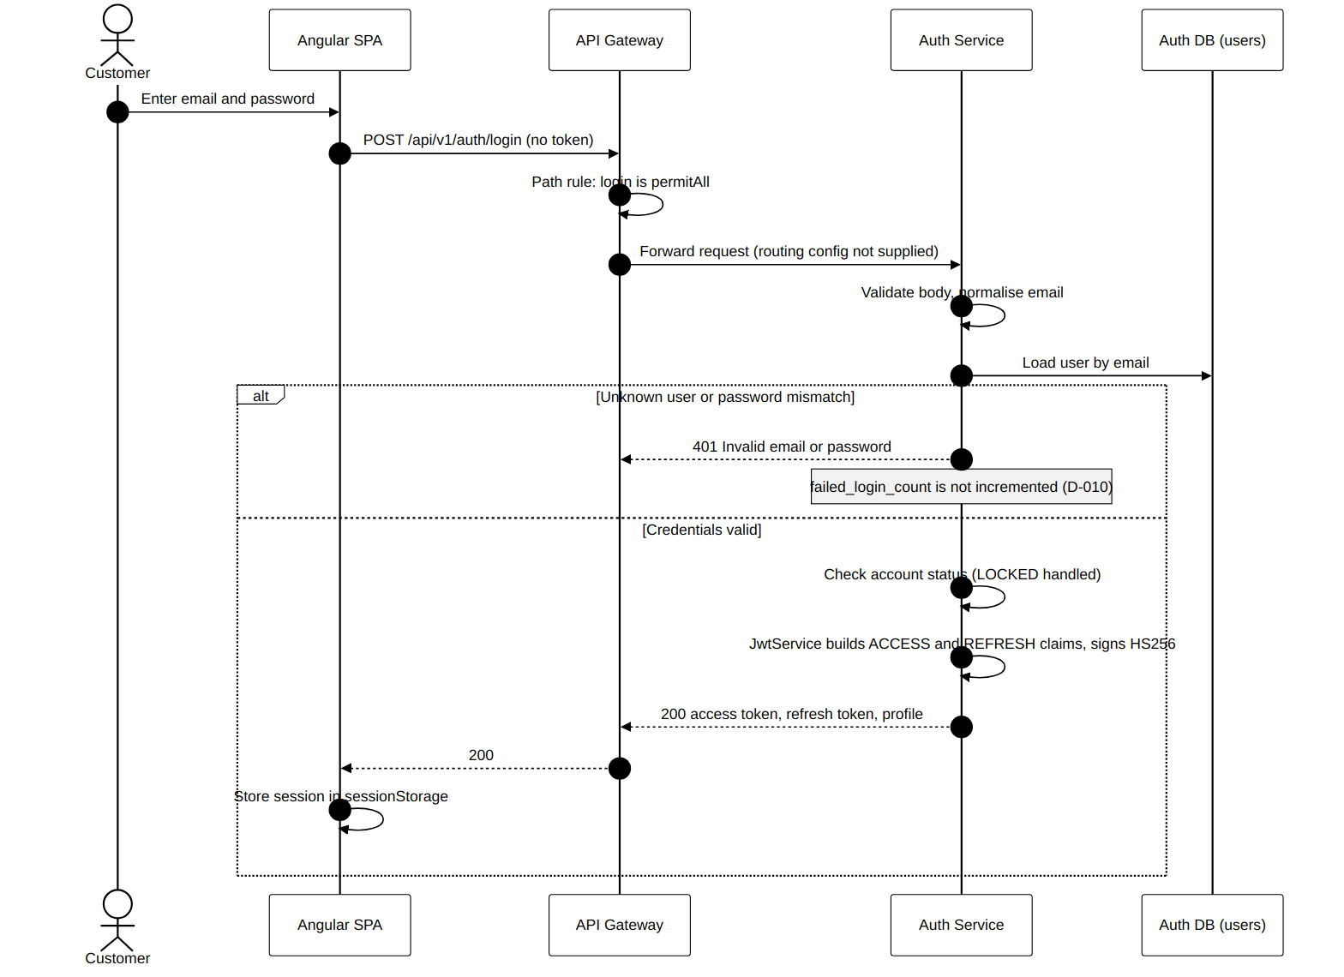
Figure 11. Login and token issuance sequence
Derived from AuthController.login, the AuthService credential check and JwtService token generation. The failure branch shows that failed attempts are not counted (D-010). The gateway routing step is inferred from the supplied path rules. Source: seq09_login.mmd.
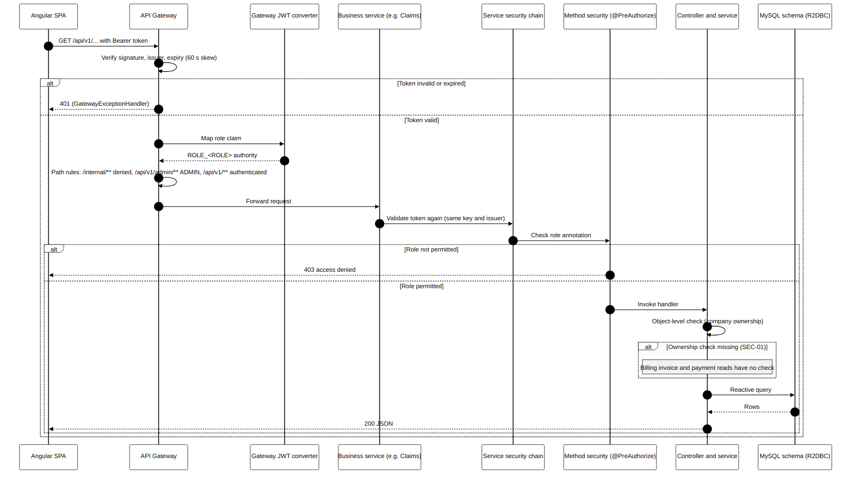
Figure 12. Protected request, JWT validation and RBAC enforcement
Combines the gateway and service checks: token verification, role-to-authority mapping, path rules, method-level @PreAuthorize and object-level ownership checks. The note marks the Billing reads that have no ownership check (SEC-01). Source: seq10_protected_request.mmd.
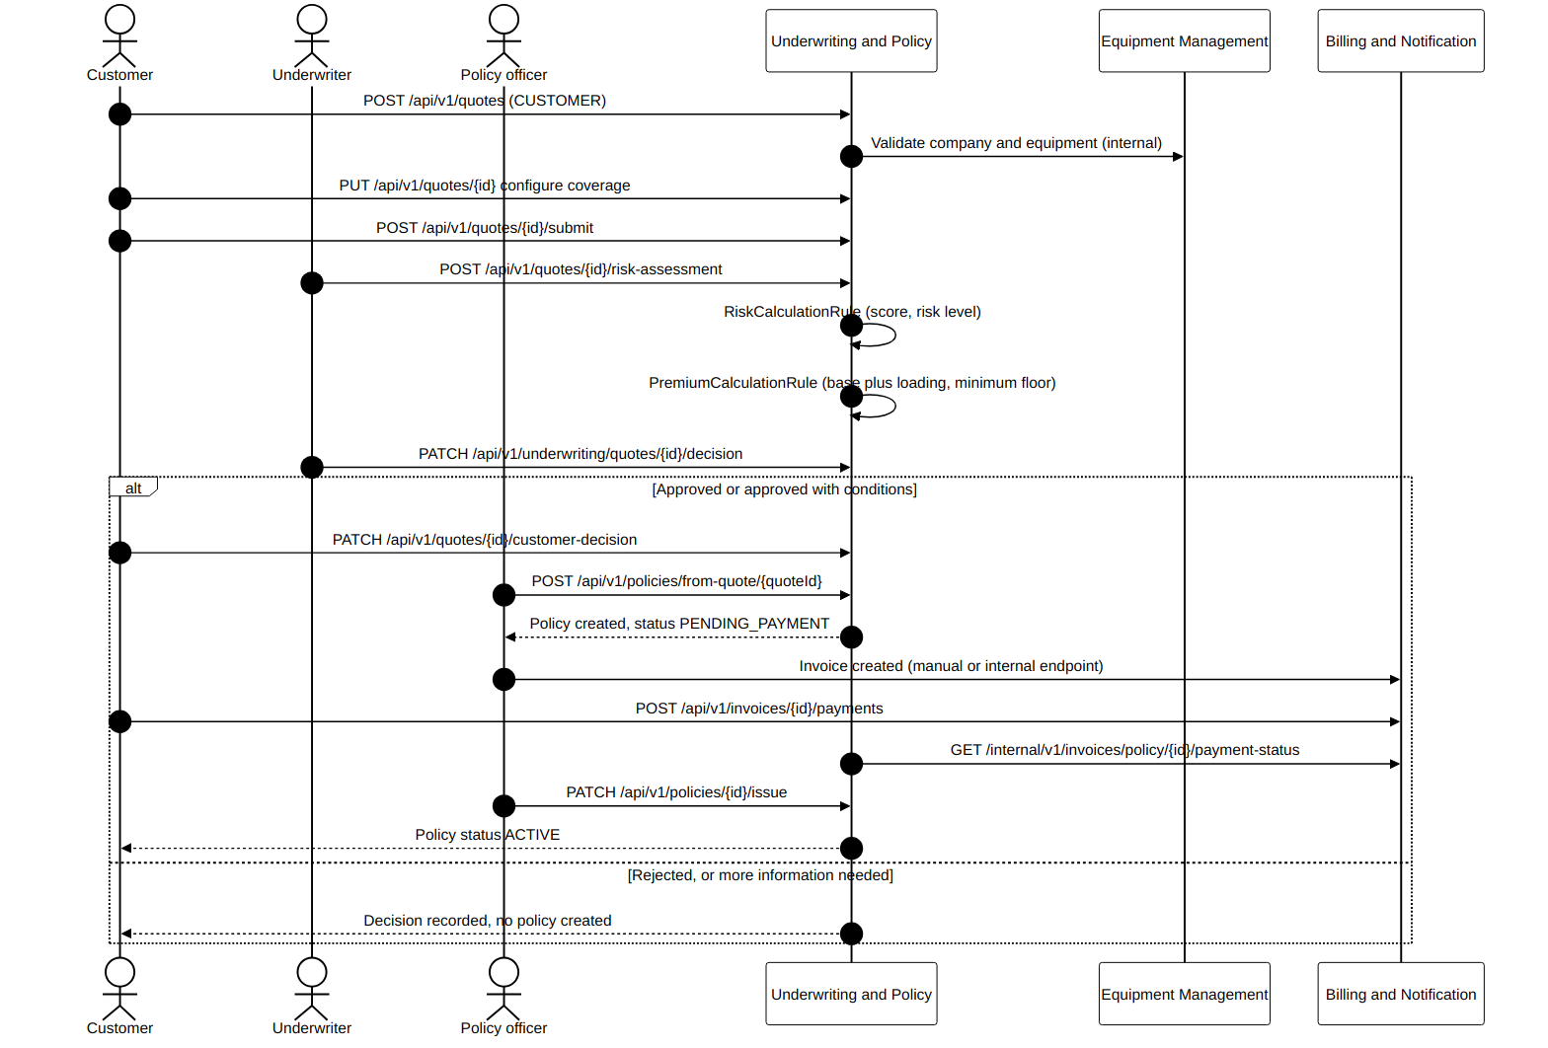
Figure 13. Quotation to policy sequence
Ordering follows the domain workflow and the endpoint dependencies. The step where payment precedes issue is inferred from the payment-status call made by the Underwriting service; the exact guard in issuePolicy was not reviewed. Source: seq11_quote_to_policy.mmd.
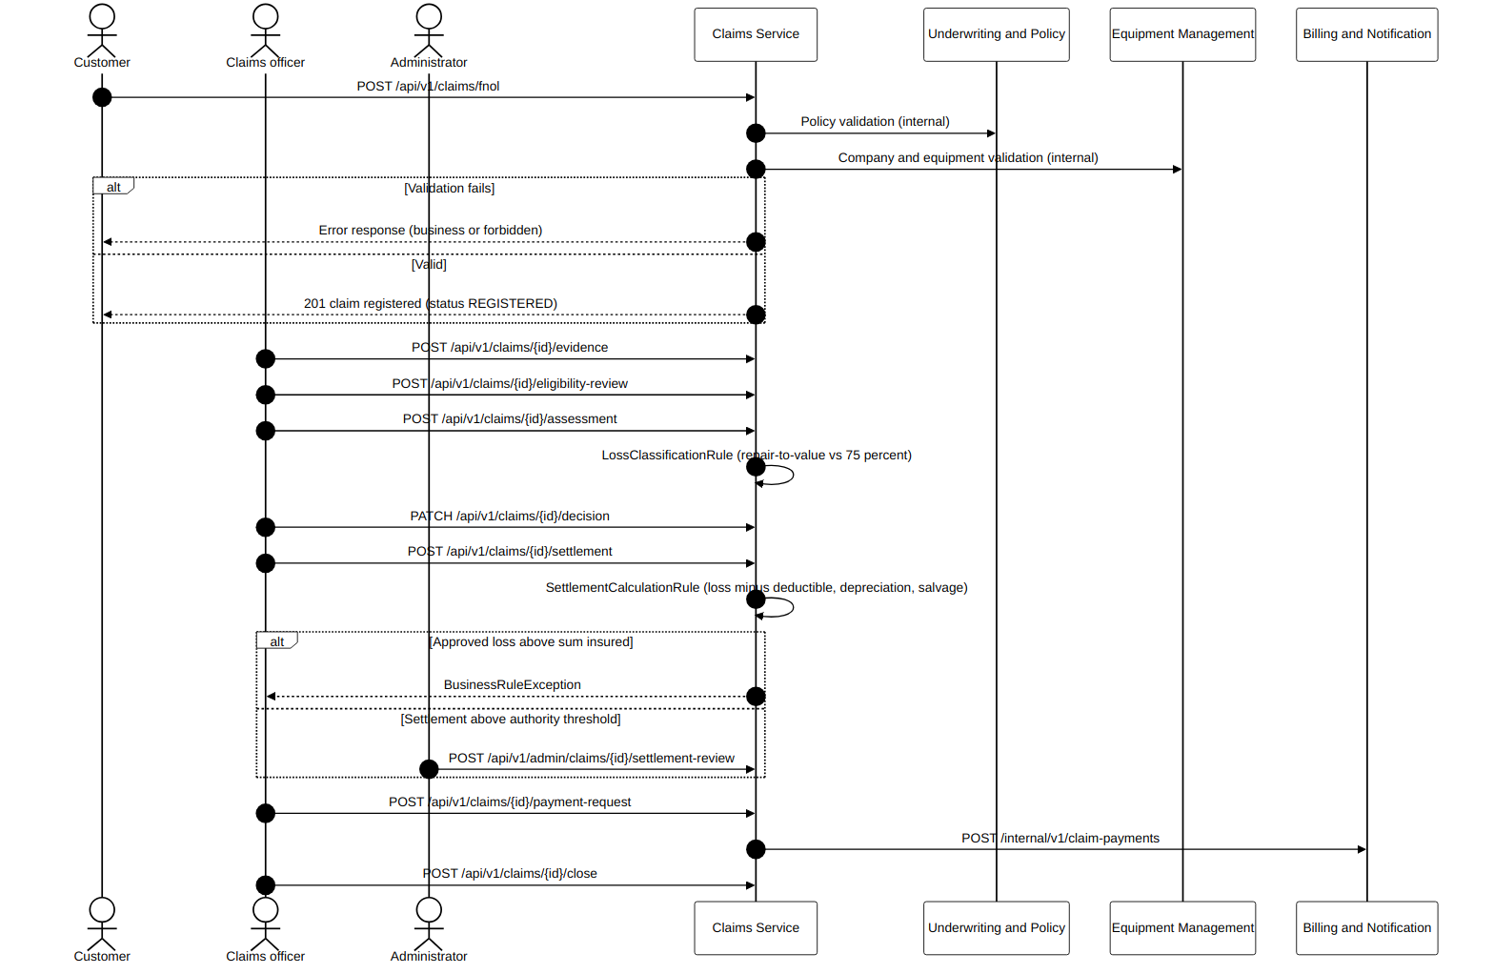
Figure 14. FNOL to settlement sequence
Derived from the claim controllers and the internal clients. The validation applied at FNOL was not traced line by line, so the failure branch is shown generically. The settlement branch reflects SettlementCalculationRule. Source: seq12_fnol_to_settlement.mmd.

5.4 Activity and state diagrams
The claim settlement activity is split into two parts. The state diagrams show the status values held in the code; transitions that cannot be confirmed in the code are labelled as inferred.
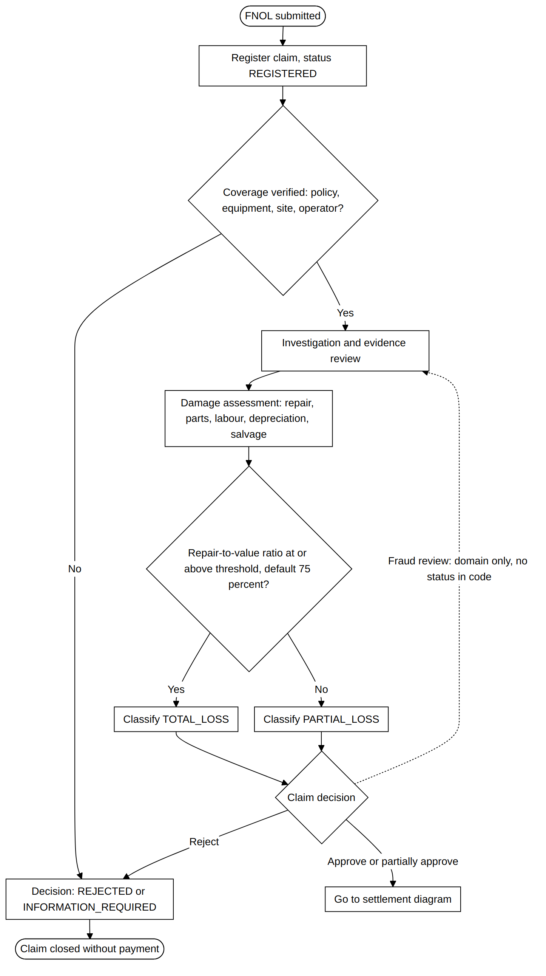
Figure 15. Claim settlement activity, part 1: coverage and assessment
Derived from the ClaimStatus values, LossClassificationRule and the claim endpoints. The fraud-review step appears in the domain document but has no status or endpoint in the code, so it is drawn as a dotted, domain-only path. Source: act13a_coverage_assessment.mmd.
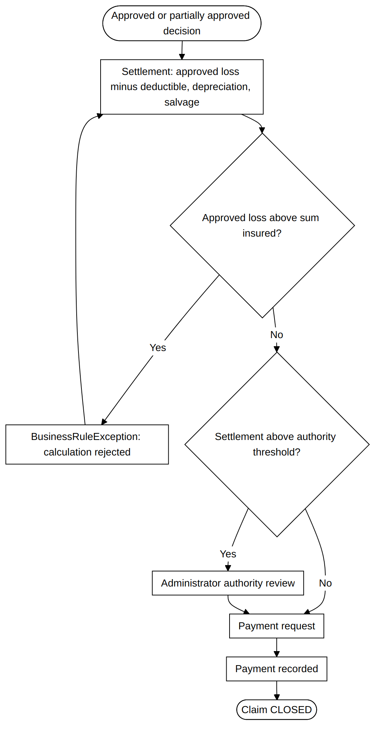
Figure 16. Claim settlement activity, part 2: settlement and payment
Derived from SettlementCalculationRule, the authority review threshold (default 1,000,000.00) and the payment-request endpoint. The calculation is rejected when the approved loss exceeds the sum insured. Source: act13b_settlement_payment.mmd.
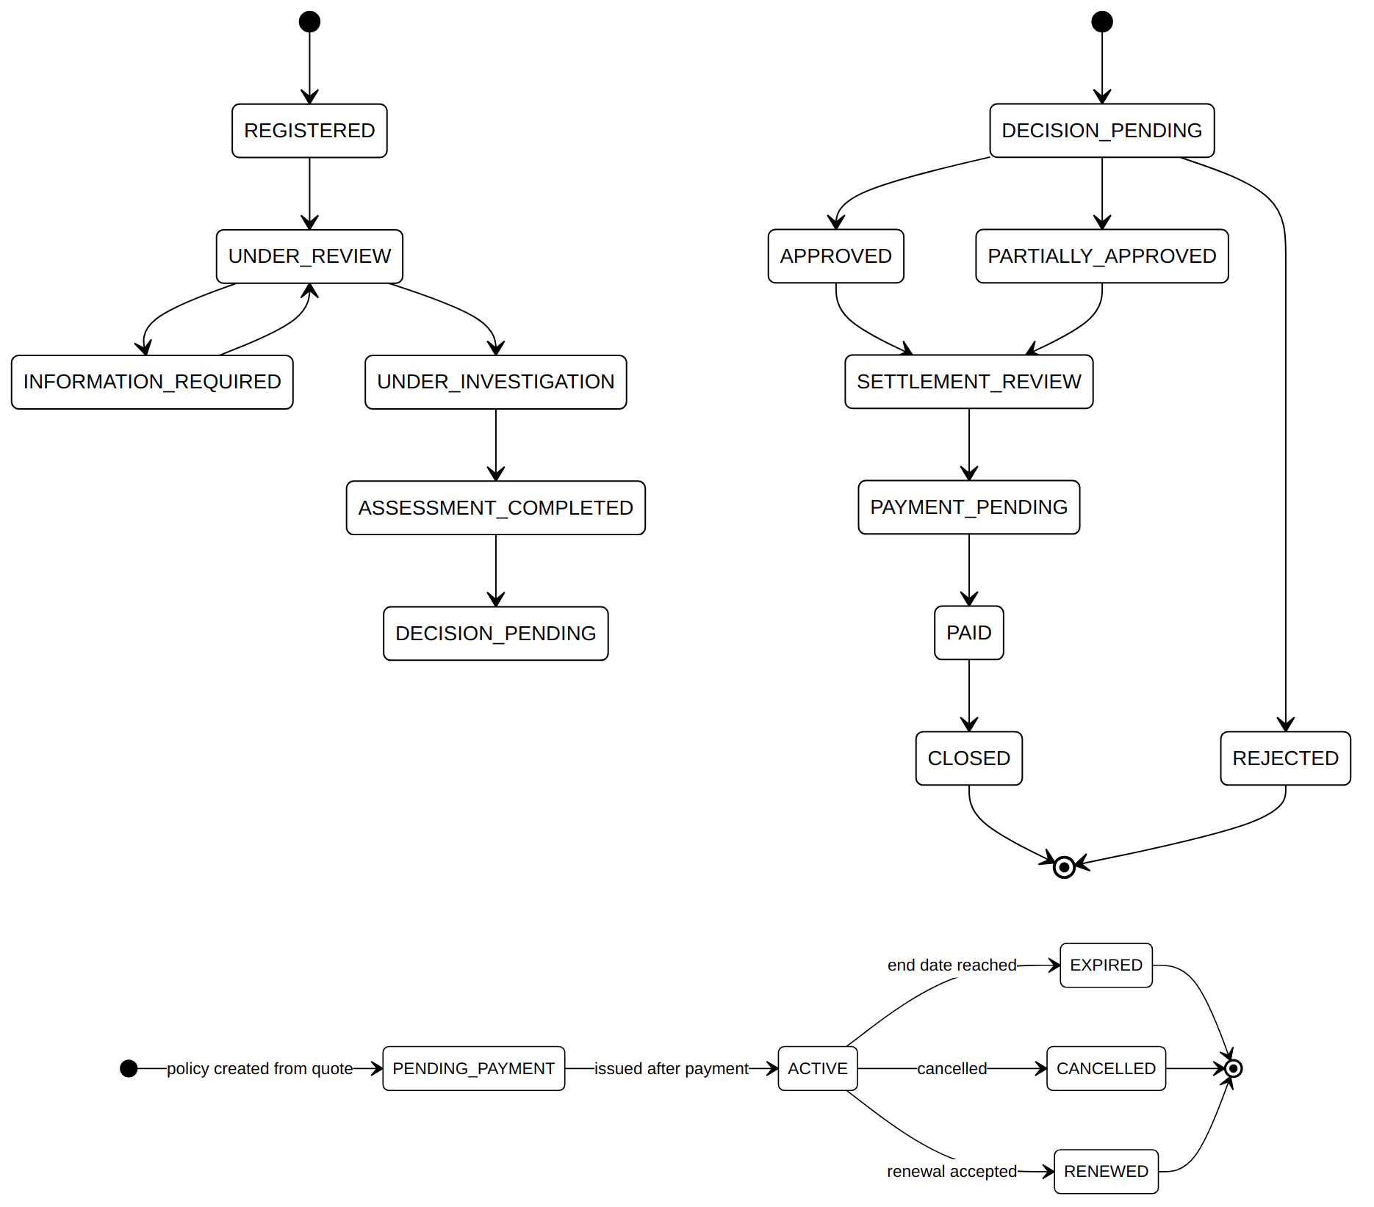
Figure 17. Policy and claim state diagrams
States are the enumerations in the code. Policy transitions are inferred from status names and the issue, expiry and renewal endpoints; claim transitions show the intended flow. DECISION_APPROVED and WITHDRAWN are omitted. Verify transitions against the service code before relying on them. Source: st14a_policy_states.mmd, st14b_claim_states_partA.mmd, st14b_claim_states_partB.mmd.

5.5 Deployment
The deployment view is limited to the evidence available: the gateway, the Eureka registry, five business services and five schemas.
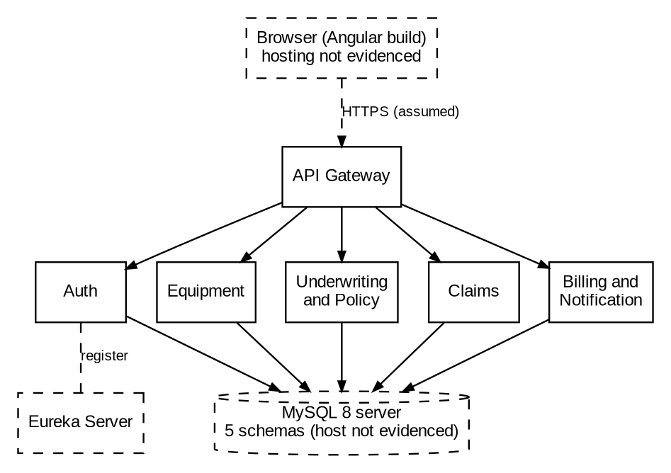
Figure 18. Deployment view (evidence level only)
Hosts, containers, ports, browser hosting and the number of service instances are not in the supplied material. They are shown dashed and are not claims about the real deployment (A-007). Source: fig15_deployment.dot.

6 User Journey and Workflow Analysis

6.1 Journey Summary
Table 8 lists the main journeys in the order the endpoints are expected to be called. Each step is taken from the controller annotations. The sequence is inferred from the domain workflow and the enumerated statuses, because no frontend routing or component-to-endpoint trace was supplied for these flows.
Table 8. Journeys, endpoints and authorization
Journey | Ordered endpoints (method and path) | Authorization | Gaps or notes
J1 Registration and sign-in | POST /api/v1/auth/register; POST /api/v1/auth/login; GET /api/v1/auth/me | Public for first two; authenticated for /me | Registration sets role CUSTOMER; no lockout (D-010)
J2 Company and master data | POST /api/v1/companies; POST /api/v1/companies/{id}/operators; POST .../project-sites; POST .../equipment; POST /api/v1/equipment/{id}/assignments | CUSTOMER for each | Company approval by ADMIN via PATCH /api/v1/admin/companies/{id}/status
J3 Quotation and underwriting | POST /api/v1/quotes; PUT /api/v1/quotes/{id}; POST /api/v1/quotes/{id}/submit; POST /api/v1/quotes/{id}/risk-assessment; PATCH /api/v1/underwriting/quotes/{id}/decision; PATCH /api/v1/quotes/{id}/customer-decision | CUSTOMER; UNDERWRITER or ADMIN | Premium excludes discounts and optional coverage (D-006)
J4 Policy issuance and billing | POST /api/v1/policies/from-quote/{quoteId}; PATCH /api/v1/policies/{id}/issue; POST /api/v1/invoices; POST /api/v1/invoices/{id}/payments | POLICY_OFFICER or ADMIN; payment by CUSTOMER | Internal POST /internal/v1/invoices is public at service level (SEC-04)
J5 Endorsement | POST /api/v1/policies/{id}/endorsements; PATCH /api/v1/underwriting/endorsements/{id}/decision; PATCH /api/v1/endorsements/{id}/issue | CUSTOMER; UNDERWRITER; POLICY_OFFICER | No day-count pro-rata (D-007)
J6 FNOL to closure | POST /api/v1/claims/fnol; POST /api/v1/claims/{id}/evidence; POST .../eligibility-review; POST .../assessment; PATCH .../decision; POST .../settlement; POST /api/v1/admin/claims/{id}/settlement-review (if above threshold); POST .../payment-request; POST .../close | CUSTOMER for FNOL; CLAIMS_OFFICER or ADMIN for the rest | Evidence upload restricted to staff (D-014)
J7 Renewal | GET /api/v1/renewals/policies/{id}/eligibility; POST /api/v1/renewals/policies/{id}; GET /api/v1/renewals/queue | CUSTOMER; POLICY_OFFICER or ADMIN | Domain renewal outcomes only partly reviewed

6.2 Lifecycle States
Table 9 lists the status values defined in the code for the main workflow entities. These are the states the workflow moves through. Transition rules were not fully reviewed, so the list is a state inventory rather than a verified state machine.
Table 9. Status values defined in the code
Entity | Status values (from enumerations)
Quote | DRAFT, SUBMITTED, UNDER_REVIEW, INFORMATION_REQUIRED, INSPECTION_REQUIRED, APPROVED, REJECTED, ACCEPTED, DECLINED, EXPIRED
Underwriting outcome | APPROVED, APPROVED_WITH_CONDITIONS, INFORMATION_REQUIRED, INSPECTION_REQUIRED, REJECTED
Policy | PENDING_PAYMENT, ACTIVE, EXPIRED, CANCELLED, RENEWED
Endorsement | SUBMITTED, UNDER_REVIEW, APPROVED, REJECTED, PENDING_PAYMENT, ISSUED, CANCELLED
Claim | REGISTERED, UNDER_REVIEW, INFORMATION_REQUIRED, UNDER_INVESTIGATION, ASSESSMENT_COMPLETED, DECISION_PENDING, DECISION_APPROVED, APPROVED, PARTIALLY_APPROVED, REJECTED, WITHDRAWN, SETTLEMENT_REVIEW, PAYMENT_PENDING, PAID, CLOSED
Claim decision | APPROVED, PARTIALLY_APPROVED, REJECTED, INFORMATION_REQUIRED, UNDER_INVESTIGATION
Loss classification | UNDETERMINED, PARTIAL_LOSS, TOTAL_LOSS
Invoice | ISSUED, PARTIALLY_PAID, PAID, OVERDUE, CANCELLED, REFUNDED
Payment | PENDING, COMPLETED, FAILED, CANCELLED, REFUNDED
Risk level | Equipment module: LOW, MEDIUM, HIGH. Underwriting module: LOW, MEDIUM, HIGH, VERY_HIGH

7 Functional Requirements and Business Rules
Requirements are given stable identifiers (FR for functional, BR for business rule). Each row states the source, the implementing code, the database objects, and the status. The status vocabulary is: Implemented (code present), Partial (some elements missing), Missing (no code found), Inconsistent (code and source disagree), and Unverified (code present but not reviewed in detail). Test evidence is listed as a class name where one exists. No requirement has been verified by execution.
Table 10. Requirements traceability (domain document to code)
ID | Requirement or rule | Implementation evidence | Database objects | Status
FR-001 | Customers self-register; accounts are customer accounts | AuthService.register; UserMapper sets CUSTOMER; AuthServiceTest | users | Implemented
FR-002 | Company registration with administrator approval | CompanyController.createCompany; updateCompanyStatus (ADMIN) | companies | Implemented
FR-003 | Equipment records with values, serial number and condition | EquipmentController; Equipment entity | equipment | Implemented
FR-004 | Operators with licence, experience and authorised equipment types | OperatorController; Operator entity | operators | Implemented
FR-005 | Project sites with security, flood and theft exposure | ProjectSiteController | project_sites | Implemented
FR-006 | Equipment assignment to operator and site without overlap | EquipmentAssignmentService overlap count | equipment_assignments | Implemented
FR-007 | Maintenance history per equipment | MaintenanceController | maintenance_records | Implemented
FR-008 | Quote configuration, submission and customer decision | QuoteController; CustomerQuoteDecisionController | quotes | Implemented
FR-009 | Risk score from six factors, classified into bands | RiskAssessmentController; RiskCalculationRule | risk_assessments | Inconsistent (D-001)
FR-010 | Underwriting decisions including conditions and inspection | UnderwritingController; QuoteStatus and UnderwritingOutcome enums | quotes | Implemented
FR-011 | Policy issued from approved quote | PolicyController.createPolicy; PolicyIssuanceController | policies, policy_equipment | Implemented
FR-012 | Endorsement request, review, issue | EndorsementController; EndorsementService; EndorsementIssuanceController | endorsements | Partial (premium rule, D-007)
FR-013 | FNOL with policy, machine and site | ClaimController.registerClaim | claims | Implemented
FR-014 | Coverage eligibility checks (policy, equipment, site, operator) | ClaimEligibilityController; InternalPolicyValidationController.validateCoverage | claim_assessments | Unverified
FR-015 | Renewal eligibility and renewal quote | RenewalController; RenewalService | policies, quotes | Unverified
FR-016 | Invoices and payments with duplicate protection | InvoiceController; InvoicePaymentController; idempotency_key | invoices, payments | Implemented
FR-017 | Notifications to users | NotificationController; Notification entity | notifications (no DDL) | Inconsistent (D-003)
BR-001 | Premium equals sum insured times base rate, plus risk loading, not below minimum | PremiumCalculationRule | policies | Implemented
BR-002 | Insured value equals equipment cost plus freight, taxes and installation | No matching logic found | None | Missing (D-005)
BR-003 | Discounts and optional coverage costs added to premium | No matching logic found | None | Missing (D-006)
BR-004 | Settlement equals approved loss minus deductible, depreciation and salvage, not negative | SettlementCalculationRule.calculate | claim_settlements | Implemented
BR-005 | Approved loss cannot exceed equipment sum insured | SettlementCalculationRule | claim_settlements | Implemented
BR-006 | Total loss when repair-to-value ratio meets threshold (default 75%) | LossClassificationRule | claim_assessments | Implemented
BR-007 | Settlement above authority threshold requires administrator review | SettlementCalculationRule; SettlementAuthorityReviewController | claim_settlements | Implemented
BR-008 | Endorsement premium pro-rated by remaining days | Not found; premium supplied by underwriter | endorsements | Missing (D-007)
BR-009 | Valuation by replacement cost, actual cash value, market value, agreed value | Stored values only; no ACV or agreed-value calculation | equipment, policy_equipment | Partial (D-008)
BR-010 | Deductible types (fixed, percentage, theft, flood, per-item) | Single deductible_amount; no type found | policy_equipment | Partial (D-009)
BR-011 | Account lock after failed sign-ins | failed_login_count never incremented | users | Missing (D-010)

7.1 Non-Functional Concerns
Security is covered in Chapter 9. Reliability is limited by the absence of retry, timeout and circuit-breaker behaviour between services (Section 3.6). Maintainability is supported by a consistent layered structure in each module (controller, service, rule, DTO, mapper, repository) and by Lombok. Usability is outside the scope of the supplied evidence, apart from the role-aware routing and guards in the frontend. Performance and scalability cannot be assessed: no load test, benchmark or capacity configuration was supplied, and the report does not propose numeric targets.

8 API Documentation

8.1 Endpoint Summary
The supplied backend has 102 REST handlers. Table 11 counts them by module and HTTP method. The full catalogue, with handler, path and authorization for each endpoint, is in Appendix A. The catalogue is derived from source annotations and has not been checked against a running service.
Table 11. Endpoint counts by module and method
Module | GET | POST | PATCH | PUT | Total
Auth | 3 | 5 | 5 | 0 | 13
Equipment | 16 | 6 | 1 | 0 | 23
Underwriting | 17 | 6 | 5 | 1 | 29
Claims | 6 | 8 | 1 | 0 | 15
Billing | 12 | 8 | 2 | 0 | 22
Total | 54 | 33 | 14 | 1 | 102

Of the 102 handlers, 77 are restricted by role through @PreAuthorize (38 with a single role, 39 with several roles). Fifteen require an authenticated user of any role. Ten have no method-level or class-level annotation and rely on the service security rule for authentication (the endpoints of the Auth service and the internal endpoints). The Swagger and OpenAPI annotations are present in the controllers, but no generated OpenAPI document was supplied, so no OpenAPI specification is provided in this revision.

8.2 Conventions
Public-facing paths use the /api/v1 prefix and internal service-to-service paths use /internal/v1. Administrative paths use /api/v1/admin. Correlation identifiers use the X-Correlation-ID header, which the gateway and each service filter read or create. The error response shape is defined in the gateway (GatewayErrorResponseDTO); the response shape of the business services was not reviewed in full.

8.3 Frontend Callers
The frontend has twenty API client classes (Appendix D). Each takes its paths from configuration keys, for example config.api.endpoints.claim.list, so the frontend-to-backend path map cannot be verified without the runtime JSON file (D-015). The client method names do map by meaning to the backend handlers. For example, the claim client methods list, create, getById and addEvidence correspond to the claim listing, FNOL, claim retrieval and evidence endpoints in ClaimController.

9 Security, Authentication, JWT and RBAC

9.1 Authentication and Authorization
Authentication establishes who the caller is. Authorization establishes what that caller may do. In this system, authentication is performed by the Auth service, which issues signed tokens. Each service then authenticates requests by validating the token, and authorizes them by comparing the role claim against method annotations and path rules.

9.2 Credential Processing
Passwords are hashed with BCrypt through a PasswordEncoder bean, present in four modules. Registration and password change require a password of 8 to 72 characters. Email addresses are trimmed and lower-cased before storage and lookup. Login failures return the same message whether the email or the password is wrong, which avoids revealing which accounts exist. AuthService also maps the LOCKED account status to a specific login error. The failed-login counter is reset to zero on successful login, but it is never incremented on failure, so lockout by repeated failure is not implemented (D-010).

9.3 JWT Issuance and Validation
The Auth service issues two token types with the same HS256 signing key: an ACCESS token and a REFRESH token. Both carry the claims iss (issuer), sub (lower-cased email), iat, exp, userId, role, tokenType, and mustChangePassword, and companyId when the user is linked to a company. The signing key is created from the configured secret, which must be at least 32 UTF-8 bytes; the value is not reproduced here. Validation in every service checks the signature with the same key and uses the HS256 algorithm, checks the issuer, and applies timestamp validation with a 60-second clock-skew allowance. Token lifetimes are configured externally and cannot be confirmed. There is no token revocation list and no logout endpoint, because logout is disabled in every security configuration.

9.4 Filter Chains and Public and Protected Routes
Table 12. Route policy by service
Service | Public (permitAll) | Protected rule | Observation
API Gateway | Preflight; Swagger and OpenAPI paths; POST register, register/users, login, refresh; health, info and metrics actuator paths | /api/v1/admin/ requires ADMIN; /api/v1/ authenticated; /internal/** denied; anything else denied | Gateway denies internal paths, which protects internal endpoints from external callers
Auth | Preflight; Swagger; POST register, register/users, login, refresh; POST actuator paths; PATCH /internal/v1/users/*/company/* | GET /me and PATCH change-password authenticated; all other requests authenticated | Internal company-link endpoint is public at service level (SEC-04)
Equipment Management | Preflight; Swagger; health | /api/v1/admin/ requires ADMIN; /internal/v1/ and /api/v1/** authenticated | Method annotations add CUSTOMER restrictions
Underwriting and Policy | Preflight; Swagger; health | /internal/v1/ and /api/v1/ authenticated | Role restrictions at method level
Claims | Preflight; Swagger; health | /internal/v1/ and /api/v1/ authenticated | Object-level checks in ClaimService
Billing and Notification | Preflight; Swagger; health; POST /internal/v1/invoices; GET invoice payment-status (see note) | /api/v1/ and /internal/v1/ authenticated; notifications authenticated | GET payment-status permitAll rules come after the /internal/v1/** rule, so they are not applied (SEC-05)

9.5 Role-Based Access Control
Roles are stored as role names (for example ADMIN). The gateway and services convert the role claim into a ROLE_ prefixed authority, so @PreAuthorize("hasRole('ADMIN')") matches the claim value ADMIN. Reactive method security is enabled with @EnableReactiveMethodSecurity in the four business services. The frontend contains route guards (authGuard, roleRedirectGuard, passwordChangeRequiredGuard and passwordChangeRequiredMatchGuard) that control navigation. These guards are a user-experience control; the backend rules are the enforcement point. The mustChangePassword claim is carried in the token and the frontend redirects users to a password change page. Server-side enforcement of this claim, such as blocking other endpoints until the password is changed, was not located in the supplied code, so it is unverified.

9.6 CORS, CSRF, Sessions and Logout
CSRF protection is disabled in every service, which is appropriate for bearer-token APIs that do not rely on cookies. CORS is configured in each module through a CORSConfiguration class; the allowed origins were not reviewed in detail. Session management is not configured explicitly in any service security configuration, so the reactive security default applies, and the code does not use server-side sessions. Form login, HTTP Basic and logout are disabled. Tokens are kept in the browser sessionStorage (Section 9.7).

9.7 Security Findings
The findings below are based on the code as supplied. Confidence is shown as Confirmed (present in code and clear from reading it) or Inferred (plausible from the code but needing a runtime test). None has been reproduced by testing, and the report does not claim they are exploitable. Secret values are not reproduced.
Table 13. Security findings
ID | Finding and evidence | Impact | Confidence and remediation
SEC-01 | Object-level access missing for invoices and payments. InvoiceService.getInvoice and getInvoiceByNumber look up by identifier or number without company comparison; PaymentQueryService.getPayment and getByTransactionReference do the same; PaymentController requires only an authenticated user. | A user of one company could read invoice or payment records of another company if identifiers are known or guessed (IDOR). | Confirmed in code; runtime not tested. Add company-ownership checks against the JWT company claim, and add cross-company tests.
SEC-02 | Refresh tokens are not rejected by resource servers. Only the Auth service checks tokenType; other services validate signature and issuer only. | If the refresh token is accepted as a bearer token, its longer lifetime extends the window of misuse. | Inferred; test with a refresh token against /api/v1 endpoints. Enforce tokenType ACCESS in every resource server.
SEC-03 | No lockout or throttling for repeated failed sign-ins. Failed-login counter is never incremented. | Enables password guessing against known accounts. | Confirmed in code. Increment on failure, lock after a configured threshold, and add rate limiting at the gateway.
SEC-04 | Internal endpoints are public at service level. Auth PATCH /internal/v1/users/*/company/* is permitAll; Billing POST /internal/v1/invoices is permitAll. The gateway denies /internal/**. | Security depends on the gateway being the only path to these services. Any direct route to the service would expose the endpoints. | Confirmed in configuration; exposure depends on network design (unverified). Require service authentication on internal endpoints.
SEC-05 | Billing payment-status rules are shadowed. GET /internal/v1/invoices/*/payment-status is permitAll but appears after /internal/v1/** authenticated. | The intended public access is not applied; the callers in Underwriting must present a valid token or the call fails. | Confirmed by rule order; intent unclear. Correct the rule order or remove the rule.
SEC-06 | Public bulk registration. POST /api/v1/auth/register/users accepts a list of users without authentication, and no rate limit is visible. | Can be used to create large numbers of accounts. | Confirmed endpoint; rate limiting not verified. Require approval or rate limiting.
SEC-07 | Tokens in browser sessionStorage. auth-session.storage.ts stores the authentication session in sessionStorage. | A script injected into the page could read the stored session (XSS exposure). sessionStorage is cleared when the tab closes. | Confirmed in code. Reduce token lifetime, enforce a strict content security policy, consider HTTP-only cookies.
SEC-08 | No revocation and no logout. Logout is disabled and no revocation list exists. | A stolen token remains valid until its expiry. | Confirmed in code. Keep lifetimes short and add a revocation or session-version check.
SEC-09 | One signing secret for HS256 across all services. Each service reads security.jwt.secret. | Any service that holds the key can mint tokens accepted by every other service. Key rotation affects all services. | Inferred from identical configuration keys; values not supplied. Plan asymmetric keys (RS256 or EdDSA) with a JWKS endpoint.

10 Validation, DTOs and Exception Handling

10.1 Validation Layers
Validation occurs at five levels. Frontend forms and guards provide first-line checks; their rules were not reviewed in detail. Bean Validation annotations on request records reject malformed input before the service runs (for example, a full name of 2 to 100 characters and a valid email). Business rules are enforced in service and rule classes, which throw BusinessRuleException for violations (for example, a settlement above the sum insured). Authorization checks use @PreAuthorize and ForbiddenOperationException. Database CHECK and UNIQUE constraints form the last layer.

10.2 Exception Model
The supplied code defines domain exceptions including BusinessRuleException, ResourceNotFoundException, ForbiddenOperationException, DuplicateResourceException and AuthenticationException. Global handlers annotated with @RestControllerAdvice and @ExceptionHandler appear in six modules, including the gateway. The mapping from each exception to an HTTP status was not fully traced for every service. The gateway handler produces GatewayErrorResponseDTO. The four business-service GlobalExceptionHandler classes in the business services call log methods, but no logger declaration is visible in the supplied file (D-018).

10.3 Validation Matrix
Table 14. Validation rules by field and layer
Field or rule | Rule | Failure outcome | Implementation
Password (registration and change) | 8 to 72 characters; not blank | Validation error on request | UserRegistrationRequestDTO; ChangePasswordRequestDTO
Full name | 2 to 100 characters | Validation error | UserRegistrationRequestDTO
Email | Valid format; unique | Validation error; duplicate error | DTO @Email; users.email unique; AuthService.register
Approved loss amount | Not negative; not above sum insured | BusinessRuleException | SettlementCalculationRule.calculate
Settlement deductible, depreciation, salvage | Not negative | BusinessRuleException | SettlementCalculationRule.validateAmount
Settlement authority review | Above threshold (default 1,000,000.00) sets PENDING review | Status change, not error | SettlementCalculationRule; claim_settlements.authority_review_status
Repair-to-value ratio | Pre-loss value greater than zero; ratio at or above threshold is total loss | BusinessRuleException; classification | LossClassificationRule; chk_claim_assessment_ratio
Risk score | Between 0 and 100 | BusinessRuleException | PremiumCalculationRule.validateInput; chk_total_risk_score
Premium | Not below minimum; base rate applied to sum insured | Floor applied | PremiumCalculationRule.calculate
Endorsement premium adjustment | Not negative | BusinessRuleException | EndorsementService (validation block)
Conditional endorsement approval | At least one condition | BusinessRuleException | EndorsementService (validation block)
Equipment values and year | Values greater than zero; year at least 1900 | Database check error | equipment CHECK constraints
Project site dates | End date not before start date | Database check error | chk_project_site_dates
Equipment assignment | No overlapping assignment for same equipment | Business error: "Equipment already has an overlapping assignment" | EquipmentAssignmentService overlap count
Invoice payment | Paid amount between zero and invoice amount | Database check error | chk_invoice_amount_paid
Payment idempotency | Idempotency key unique | Duplicate detected | uk_payments_idempotency_key

10.4 Frontend Error Display
The frontend includes an AppConfigError type for configuration failures and error and not-found pages for routing failures. How backend error bodies are presented in individual components was not traced, so the end-to-end error path from backend response to user message is unverified.

11 Testing and Code Coverage

11.1 Test Inventory
The supplied material contains 32 backend test files with 228 @Test annotations, and one frontend spec file. Table 15 summarises the inventory. Most of the test code is in the Auth service and the API gateway. Each of the other services has a single Spring context test. Appendix C lists every test file.
Table 15. Test inventory summary
Module | Test files | @Test annotations | Test types present
Auth | 21 | 206 | Unit tests with Mockito (services, controllers, JWT, DTO validation, mappers); configuration tests; one application context test
API Gateway | 6 | 17 | Unit tests for security configuration, JWT converter, correlation filter, exception handler; application context test
Billing and Notification | 1 | 1 | Application context test only
Claims | 1 | 1 | Application context test only
Equipment Management | 1 | 1 | Application context test only
Underwriting and Policy | 1 | 1 | Application context test only
Eureka Server | 1 | 1 | Application context test only
Frontend (Angular) | 1 | not counted | Single spec file (app.spec.ts); test content not reviewed

The 228 annotations show the number of test methods written, not the number executed, passed or covering code. No execution results were supplied, so the report does not state that any test passes.

11.2 Code Coverage
No coverage report was supplied for either the backend or the frontend. Coverage is therefore unavailable, and this report gives no coverage percentage. Measured coverage should be obtained before any coverage claim is made. For the Java modules, a JaCoCo report generated by the build (for example, through the Maven or Gradle JaCoCo plugin) gives line and branch coverage per module. For the Angular application, the test runner can produce coverage with the code-coverage option of the Angular CLI test command, or with the coverage option of the chosen test framework. The output should be stored with the build number and the commit identifier so the figures can be traced.

11.3 Gaps and Recommended Test Plan
The existing tests are mainly unit tests of the Auth service. The following areas have no test evidence in the supplied material, and the report recommends them as priorities. Each recommended test includes negative and authorization cases, as the master specification requires.
Table 16. Recommended test cases
ID | Module | Scenario | Expected result | Status in supplied material
TC-001 | Billing | Customer of company A requests invoice of company B by identifier | 403 or 404; no data returned | Not present (SEC-01)
TC-002 | Billing | Customer of company A requests payment of company B by identifier | 403 or 404; no data returned | Not present (SEC-01)
TC-003 | Gateway and services | Refresh token presented on /api/v1 endpoint | 401; request rejected | Not present (SEC-02)
TC-004 | Auth | Five failed sign-ins for one account | Account locked; further attempts refused | Not present (SEC-03, D-010)
TC-005 | Billing | GET payment-status without token | Behaviour matches documented intent | Not present (SEC-05)
TC-006 | Claims | Settlement above threshold | Authority review status PENDING; no payment request before review | Not present
TC-007 | Claims | Repair-to-value at exactly the threshold | Classified TOTAL_LOSS | Not present
TC-008 | Underwriting | Endorsement premium for mid-term addition | Pro-rated premium by remaining days | Not implemented (D-007)
TC-009 | Equipment | Overlapping assignment for same equipment | Rejected with overlap error | Not present
TC-010 | Frontend | Customer opens a staff-only route | Redirected to forbidden page; no data loaded | Not present

Five backend services other than Auth and the gateway have only a context-loads test, so controller, service and repository behaviour in those services is not covered by the supplied tests.

12 Logging and Monitoring
Table 17 classifies each logging and monitoring capability as implemented, partial, absent or unverified. The classification follows the master specification: a dependency alone is not treated as evidence of monitoring.
Table 17. Logging and monitoring capabilities
Capability | Status | Evidence and comment
Application logging (SLF4J through Lombok @Slf4j) | Partial | Declared in Auth JwtService and NotificationClient; log.* calls in four GlobalExceptionHandler classes without visible declaration (D-018)
Log levels and appenders | Unverified | No logging configuration supplied
Correlation identifier propagation | Partial | CorrelationIdWebFilter in the gateway and five services reads or creates X-Correlation-ID; the identifier is not placed in the logging context (no MDC use), so log lines do not carry it
Reactive context propagation of correlation identifier | Absent | No Reactor context usage found
Sensitive-data handling in logs | Partial | Refresh-token validation logs length, segment count, issuer, subject and expiry, not the token value. Subjects are email addresses, which are personal data, logged at information level
Exception logging | Partial | log.error calls in service classes and handlers; no structured format or redaction rules
Metrics | Unverified | No Micrometer or Prometheus references in code; actuator metrics path permitted at gateway; actuator dependency not visible
Health checks | Partial | Health paths permitted in each security configuration; no custom health indicators
Distributed tracing | Absent | No tracing library or tracer references found
Dashboards and alerts | Absent | None in supplied material

The recommended improvements are structured logs with the correlation identifier in the logging context, an explicit redaction rule for email addresses and tokens, a metrics library with a scrape endpoint behind authentication, health indicators for each service database and downstream dependencies, and a tracing library that propagates the correlation identifier across WebClient calls. These are proposals; none is implemented in the supplied code.

13 Assumptions, Limitations and Future Enhancements

13.1 Assumptions Register
Table 18. Assumptions
ID | Assumption | Basis | Confidence | Validation or action
A-001 | The supplied backend Java files are the complete main and test source of the seven modules | Dump headers and package structure; no build file to confirm | Medium | Supply the build files and confirm the module list
A-002 | The SQL script is the authoritative schema with no later migrations | Only one script supplied | Medium | Confirm whether migrations exist
A-003 | The domain document is authoritative for business rules where it differs from code, except where the code is the later decision | Domain document is the stated requirements source | Medium | Decide authoritative risk bands and other rules (D-001)
A-004 | The frontend dump and backend dump describe the same release | Both are project dumps from the same source tree | Medium | Confirm release identifiers
A-005 | The frontend endpoint paths follow the backend handler paths | Client method names and resource names match | Low | Supply runtime configuration (D-015)
A-006 | Token lifetimes and secrets are set in configuration outside the dump | Code reads them as properties | High | Supply configuration with secrets redacted
A-007 | Deployment uses container or cluster naming | Service host names used in clients | Low | Supply deployment files

13.2 Limitations Register
Table 19. Limitations
ID | Limitation | Effect on this report
L-001 | No build files, application configuration, gateway routes or package.json | Versions, routing and runtime settings are not stated
L-002 | No execution of code, tests or the database script | No runtime behaviour, test result or performance figure is reported
L-003 | No coverage report | Coverage is marked unavailable; no percentage is given
L-004 | Frontend runtime configuration JSON not supplied | Frontend-to-backend path mapping is incomplete (D-015)
L-005 | No UML diagrams produced in this revision | Chapter 5 lists the planned diagrams only
L-006 | Business services reviewed at class and method level, not line by line | Some rules are marked Unverified (Table 10)
L-007 | Frontend components not traced one by one to their API calls | Journeys in Table 8 are inferred from the domain workflow and endpoint annotations
L-008 | No OpenAPI document generated | Chapter 8 and Appendix A are derived from annotations and are unverified

13.3 Discrepancy Register
Appendix B lists the discrepancy and gap register. Each entry gives the identifier, affected area, evidence, the gap or discrepancy, its impact, and a recommended action.

13.4 Prioritized Roadmap
Table 20. Improvement roadmap
Horizon | Improvement | Expected benefit | Relative effort | Dependencies
Short term | Add company-ownership checks to invoice and payment reads (SEC-01); add cross-company tests | Closes the most serious confirmed access gap | Low to medium | None
Short term | Enforce tokenType ACCESS in all resource servers (SEC-02) | Stops refresh-token misuse as bearer token | Low | None
Short term | Count failed sign-ins and lock accounts (SEC-03) | Limits password guessing | Low | Decision on threshold and unlock process
Short term | Correct the Billing payment-status rule order (SEC-05) and require service authentication on internal endpoints (SEC-04) | Consistent internal access | Low | Confirm callers
Short term | Add missing columns and tables to the SQL script (D-002, D-003) and map recipient fields (D-004) | Schema matches code | Low | Confirm migration approach
Short term | Resolve risk bands and enumeration (D-001) | One authoritative rule set | Low | Business decision
Medium term | Implement pro-rated endorsement premium and discounts and optional coverage (D-006, D-007) | Matches domain rules | Medium | Business rules confirmed
Medium term | Implement insured value terms and valuation methods (D-005, D-008) and deductible types (D-009) | Matches domain rules | Medium to high | Product decision
Medium term | Add metrics, health indicators, structured logs and tracing (Chapter 12) | Operational visibility | Medium | Observability platform choice
Medium term | Measure coverage in the build; add test cases TC-001 to TC-010 | Evidence for quality claims | Medium | Build files supplied
Long term | Move from shared HS256 key to asymmetric signing with a JWKS endpoint; add refresh-token rotation and revocation (SEC-08, SEC-09) | Limits blast radius of a key compromise | High | Identity design
Long term | Add retry, timeout and circuit-breaker behaviour to WebClient calls | Resilience to downstream failures | Medium | Service-level objectives

14 Conclusion
RIGVA Construction Equipment Insurance is a substantial microservices system. It has a consistent layered design across the five business services, five service databases, and a frontend organised by feature and role. Many business rules are implemented directly: the settlement formula, the total-loss threshold, the premium base and risk loading, the risk score bounds, and the endorsement and claim workflows. The schema is detailed and enforces many integrity rules.
The evidence also shows gaps that should be addressed before the system is relied upon. The most serious are the missing ownership checks on invoice and payment reads, the lack of lockout after failed sign-ins, and the absence of token-type enforcement in the resource servers. Several domain rules, including the insured value formula, pro-rated endorsement premiums, discounts and valuation methods, are not implemented. The code and the schema also disagree in three places, and the risk bands differ between the code and the domain document.
The testing position is limited. The supplied test code contains 228 test methods, mainly in the Auth service, and none of the test results has been reviewed. Coverage cannot be stated from the supplied material. The report therefore makes no claims about runtime behaviour, test success or coverage, and the next step is to supply the build files, configuration and test output so that the open items in this report can be confirmed or closed.

Appendix A Endpoint Catalogue
The catalogue lists every REST handler found in the supplied backend controllers. Authorization shows the method-level role annotation if present, otherwise the class-level annotation. Role abbreviations: CUST = CUSTOMER, UW = UNDERWRITER, PO = POLICY_OFFICER, CO = CLAIMS_OFFICER, ADM = ADMIN. "None (service rule)" means no annotation was found; access then depends on the service security rule in Table 12. The catalogue is derived from source and not checked against a running service.
Table A1. REST endpoint catalogue (102 handlers)
Module | Method | Path | Handler (class.method) | Authorization
Auth | GET | /api/v1/admin/users | AdminUserController.getUsers | ADM
Auth | GET | /api/v1/admin/users/{userId} | AdminUserController.getUser | ADM
Auth | POST | /api/v1/admin/users/staff | AdminUserController.createStaff | ADM
Auth | PATCH | /api/v1/admin/users/{userId}/status | AdminUserController.updateStatus | ADM
Auth | PATCH | /api/v1/admin/users/{userId}/role | AdminUserController.updateRole | ADM
Auth | PATCH | /api/v1/admin/users/{userId}/reset-password | AdminUserController.resetPassword | ADM
Auth | POST | /api/v1/auth/register | AuthController.register | None (service rule)
Auth | POST | /api/v1/auth/register/users | AuthController.registerUsers | None (service rule)
Auth | POST | /api/v1/auth/login | AuthController.login | None (service rule)
Auth | GET | /api/v1/auth/me | AuthController.getCurrentUser | None (service rule)
Auth | POST | /api/v1/auth/refresh | AuthController.refresh | None (service rule)
Auth | PATCH | /api/v1/auth/change-password | AuthController.changePassword | None (service rule)
Auth | PATCH | /internal/v1/users/{userId}/company/{companyId} | InternalUserController.linkCompany | None (service rule)
Billing | POST | /internal/v1/claim-payments | InternalClaimPaymentController.processClaimPayment | CO, ADM
Billing | POST | /internal/v1/invoices | InternalInvoiceController.createAutomaticInvoice | None (service rule)
Billing | GET | /internal/v1/invoices/policy/{policyId}/payment-status | InternalInvoiceController.getPolicyPaymentStatus | None (service rule)
Billing | GET | /internal/v1/invoices/endorsement/{endorsementId}/payment-status | InternalInvoiceController.getEndorsementPaymentStatus | None (service rule)
Billing | POST | /internal/v1/notifications | InternalNotificationController.createNotification | CUST, UW, PO, CO, ADM
Billing | GET | /internal/v1/payments/references/{referenceId} | InternalPaymentVerificationController.verifyPayment | Any authenticated
Billing | POST | /api/v1/invoices | InvoiceController.createInvoice | PO, ADM
Billing | GET | /api/v1/invoices/{invoiceId} | InvoiceController.getInvoice | PO, ADM
Billing | GET | /api/v1/invoices/by-number/{invoiceNumber} | InvoiceController.getInvoiceByNumber | CUST, PO, ADM
Billing | GET | /api/v1/invoices | InvoiceController.getCompanyInvoices | CUST, PO, ADM
Billing | POST | /api/v1/invoices/{invoiceId}/cancel | InvoiceController.cancelInvoice | PO, ADM
Billing | POST | /api/v1/invoices/{invoiceId}/payments | InvoicePaymentController.recordPayment | CUST, PO, ADM
Billing | GET | /api/v1/notifications | NotificationController.getNotifications | Any authenticated
Billing | GET | /api/v1/notifications/unread-count | NotificationController.getUnreadCount | Any authenticated
Billing | PATCH | /api/v1/notifications/{notificationId}/read | NotificationController.markAsRead | Any authenticated
Billing | PATCH | /api/v1/notifications/read-all | NotificationController.markAllAsRead | Any authenticated
Billing | POST | /internal/v1/invoices/process-overdue | OverdueInvoiceController.processOverdueInvoices | PO, ADM
Billing | GET | /api/v1/payments/{paymentId} | PaymentController.getPayment | Any authenticated
Billing | GET | /api/v1/payments/by-transaction/{transactionReference} | PaymentController.getByTransactionReference | Any authenticated
Billing | GET | /api/v1/payments | PaymentController.getCompanyPayments | Any authenticated
Billing | GET | /api/v1/payments/references/{referenceId} | PaymentController.getReferencePayments | Any authenticated
Billing | POST | /api/v1/invoices/{invoiceId}/refunds | PremiumRefundController.processRefund | PO, ADM
Claims | POST | /api/v1/claims/{claimId}/assessment | ClaimAssessmentController.recordAssessment | CO, ADM
Claims | POST | /api/v1/claims/{claimId}/close | ClaimClosureController.closeClaim | CO, ADM
Claims | POST | /api/v1/claims/fnol | ClaimController.registerClaim | CUST
Claims | GET | /api/v1/claims/all | ClaimController.getAllClaims | CO, ADM
Claims | POST | /api/v1/claims/{claimId}/evidence | ClaimController.addEvidence | CO, ADM
Claims | GET | /api/v1/claims/{claimId} | ClaimController.getClaim | CUST, CO, ADM
Claims | GET | /api/v1/claims | ClaimController.getCompanyClaims | CUST
Claims | PATCH | /api/v1/claims/{claimId}/decision | ClaimDecisionController.recordDecision | CO, ADM
Claims | POST | /api/v1/claims/{claimId}/eligibility-review | ClaimEligibilityController.reviewEligibility | CO, ADM
Claims | GET | /api/v1/claims/{claimId}/assessment | ClaimEligibilityController.getAssessment | CO, ADM
Claims | POST | /api/v1/claims/{claimId}/settlement | ClaimSettlementController.calculateSettlement | CO, ADM
Claims | GET | /api/v1/claims/{claimId}/settlement | ClaimSettlementController.getSettlement | CO, ADM
Claims | POST | /api/v1/claims/{claimId}/payment-request | ClaimSettlementPaymentController.requestPayment | CO, ADM
Claims | GET | /internal/v1/claims/policies/{policyId}/summary | InternalPolicyClaimsController.getSummary | Any authenticated
Claims | POST | /api/v1/admin/claims/{claimId}/settlement-review | SettlementAuthorityReviewController.reviewSettlement | ADM
Equipment | POST | /api/v1/companies | CompanyController.createCompany | CUST
Equipment | GET | /api/v1/companies/me | CompanyController.getMyCompany | CUST
Equipment | GET | /api/v1/admin/companies/{companyId} | CompanyController.getCompanyById | ADM
Equipment | PATCH | /api/v1/admin/companies/{companyId}/status | CompanyController.updateCompanyStatus | ADM
Equipment | GET | /api/v1/admin/companies | CompanyController.getCompaniesByStatus | ADM
Equipment | POST | /api/v1/equipment/{equipmentId}/assignments | EquipmentAssignmentController.createAssignment | CUST
Equipment | GET | /api/v1/equipment/{equipmentId}/assignments | EquipmentAssignmentController.getAssignments | CUST
Equipment | GET | /api/v1/equipment/{equipmentId} | EquipmentAssignmentController.getAssignment | CUST
Equipment | POST | /api/v1/companies/{companyId}/equipment | EquipmentController.createEquipment | CUST
Equipment | GET | /api/v1/companies/{companyId}/equipment | EquipmentController.getCompanyEquipment | CUST
Equipment | GET | /api/v1/companies/{companyId}/equipment/{equipmentId} | EquipmentController.getEquipment | CUST
Equipment | GET | /internal/v1/equipment/{equipmentId}/assignment-on-date | InternalAssignmentValidationController.getAssignmentOnDate | Any authenticated
Equipment | GET | /internal/v1/companies/{companyId} | InternalValidationController.getCompany | Any authenticated
Equipment | GET | /internal/v1/equipment/{equipmentId} | InternalValidationController.getEquipment | Any authenticated
Equipment | POST | /api/v1/equipment/{equipmentId}/maintenance | MaintenanceController.createMaintenanceRecord | CUST
Equipment | GET | /api/v1/equipment/{equipmentId}/maintenance | MaintenanceController.getMaintenanceHistory | CUST
Equipment | GET | /api/v1/equipment/{equipmentId}/maintenance/{maintenanceId} | MaintenanceController.getMaintenanceRecord | CUST
Equipment | POST | /api/v1/companies/{companyId}/operators | OperatorController.createOperator | CUST
Equipment | GET | /api/v1/companies/{companyId}/operators | OperatorController.getCompanyOperators | CUST
Equipment | GET | /api/v1/companies/{companyId}/operators/{operatorId} | OperatorController.getOperator | CUST
Equipment | POST | /api/v1/companies/{companyId}/project-sites | ProjectSiteController.createProjectSite | CUST
Equipment | GET | /api/v1/companies/{companyId}/project-sites | ProjectSiteController.getCompanyProjectSites | CUST
Equipment | GET | /api/v1/companies/{companyId}/project-sites/{siteId} | ProjectSiteController.getProjectSite | CUST
Underwriting | PATCH | /api/v1/quotes/{quoteId}/customer-decision | CustomerQuoteDecisionController.recordDecision | CUST
Underwriting | POST | /api/v1/policies/{policyId}/endorsements | EndorsementController.createEndorsement | CUST
Underwriting | GET | /api/v1/policies/{policyId}/endorsements | EndorsementController.getPolicyEndorsements | CUST, UW, PO, ADM
Underwriting | GET | /api/v1/underwriting/endorsements | EndorsementController.getReviewQueue | UW, ADM
Underwriting | PATCH | /api/v1/underwriting/endorsements/{endorsementId}/decision | EndorsementController.recordDecision | UW, ADM
Underwriting | PATCH | /api/v1/endorsements/{endorsementId}/issue | EndorsementIssuanceController.issueEndorsement | PO, ADM
Underwriting | GET | /api/v1/endorsements/issuance-queue | EndorsementOperationsController.getIssuanceQueue | PO, ADM
Underwriting | GET | /api/v1/insurance/quotes | InsuranceQuoteController.getAllQuotes | UW, PO, CO, ADM
Underwriting | GET | /api/v1/insurance/quotes/status/{status} | InsuranceQuoteController.getQuotesByStatus | UW, PO, CO, ADM
Underwriting | GET | /api/v1/insurance/quotes/{quoteId} | InsuranceQuoteController.getQuoteById | UW, PO, CO, ADM
Underwriting | GET | /internal/v1/policies/{policyId} | InternalPolicyValidationController.getPolicy | Any authenticated
Underwriting | GET | /internal/v1/policies/{policyId}/equipment/{equipmentId}/coverage | InternalPolicyValidationController.validateCoverage | Any authenticated
Underwriting | POST | /api/v1/policies/from-quote/{quoteId} | PolicyController.createPolicy | PO, ADM
Underwriting | GET | /api/v1/policies/{policyId} | PolicyController.getPolicy | PO, ADM
Underwriting | GET | /api/v1/policies | PolicyController.getCompanyPolicies | CUST, PO, ADM
Underwriting | PATCH | /api/v1/policies/{policyId}/issue | PolicyIssuanceController.issuePolicy | PO, ADM
Underwriting | POST | /api/v1/quotes | QuoteController.createQuote | CUST
Underwriting | PUT | /api/v1/quotes/{quoteId} | QuoteController.configureQuote | CUST
Underwriting | POST | /api/v1/quotes/{quoteId}/submit | QuoteController.submitQuote | CUST
Underwriting | GET | /api/v1/quotes/{quoteId} | QuoteController.getQuote | CUST
Underwriting | GET | /api/v1/quotes | QuoteController.getCompanyQuotes | CUST
Underwriting | GET | /api/v1/renewals/policies/{policyId}/eligibility | RenewalController.checkEligibility | CUST
Underwriting | POST | /api/v1/renewals/policies/{policyId} | RenewalController.createRenewalQuote | CUST
Underwriting | GET | /api/v1/renewals/queue | RenewalController.getRenewalQueue | PO, ADM
Underwriting | POST | /api/v1/quotes/{quoteId}/risk-assessment | RiskAssessmentController.calculateAssessment | UW, ADM
Underwriting | GET | /api/v1/underwriting/quotes | UnderwritingController.getReviewQueue | UW, ADM
Underwriting | GET | /api/v1/underwriting/quotes/{quoteId} | UnderwritingController.getQuoteForReview | UW, ADM
Underwriting | PATCH | /api/v1/underwriting/quotes/{quoteId}/decision | UnderwritingController.recordDecision | UW, ADM
Underwriting | GET | /api/v1/underwriting/quotes/history | UnderwritingController.getQuotationHistory | UW, ADM

Appendix B Discrepancy and Gap Register
Table B1. Discrepancy and gap register
ID | Area | Evidence | Gap or discrepancy, impact and confidence | Recommended action
D-001 | Risk classification | RiskCalculationRule (Underwriting): LOW up to 25, MEDIUM up to 50, HIGH up to 75, VERY_HIGH above 75. Domain: 0 to 30, 31 to 55, 56 to 75, 76 to 100. Equipment module RiskLevel has no VERY_HIGH. | Band boundaries differ. Domain "unacceptable risk" classification has no code equivalent. Impact: a quote can be classified differently from the documented rule. Confirmed. | Confirm authoritative bands; align constants and enumerations.
D-002 | users table | User entity maps must_change_password; SQL users table has no such column. | Insert or select fails if the table is created from the script. Inferred from mapping. | Add column with default in the script or migration.
D-003 | notifications | Notification entity (Billing) maps 14 fields; no CREATE TABLE in script. | Notifications cannot be persisted from the supplied schema. Confirmed. | Add table DDL with indexes on user and read status.
D-004 | payments | SQL has recipient_type and recipient_reference; Payment entity does not map them. | Payee information cannot be stored or read through code. Confirmed. | Map the columns or remove them.
D-005 | Insured value | Domain: equipment cost plus freight, taxes and installation. No matching terms in code. | Insured value may understate the amount the domain requires. Confirmed by absence. | Confirm rule; implement or record as domain-only.
D-006 | Premium | Domain adds optional coverage cost and subtracts discounts. PremiumCalculationRule computes base plus risk loading with a minimum floor. | Premium excludes optional coverage and discounts. Confirmed. | Implement or document as not in scope.
D-007 | Endorsement premium | Domain: annual premium times remaining days over total days; refund on removal. EndorsementService takes an underwriter-entered adjustment that must be non-negative. | No pro-rata calculation and no refund path for removal. Confirmed. | Implement day-count calculation and negative adjustments.
D-008 | Valuation methods | Domain lists replacement cost, actual cash value, market value, agreed value and sum insured. Code stores purchase, market and replacement values only. | Actual cash value and agreed value not calculated. Confirmed by absence. | Confirm which methods apply to which product.
D-009 | Deductible types | Domain lists fixed, percentage, equipment-specific, theft, flood, per-item and per-incident. Code stores a single deductible amount. | No deductible type field found. Confirmed by absence. | Add type model if required.
D-010 | Failed sign-in lockout | failed_login_count only set to zero; AuthService does not increment on bad password. | Lockout by failures never happens; LOCKED only set manually. Confirmed. | Increment and lock at a threshold (SEC-03).
D-011 | Billing payment-status rules | GET rules with permitAll follow /internal/v1/** authenticated in Billing SecurityConfiguration. | Rules never applied; behaviour differs from intent. Confirmed by order. | Correct order or remove rules (SEC-05).
D-012 | Token type | Only Auth JwtService and AuthResponseDTO handle tokenType. Resource servers validate signature and issuer. | Refresh tokens may be accepted as bearer tokens. Inferred (SEC-02). | Enforce ACCESS type in every resource server.
D-013 | Object-level access | InvoiceService.getInvoice, getInvoiceByNumber; PaymentQueryService.getPayment, getByTransactionReference. | Cross-company read possible. Confirmed in code; runtime not tested (SEC-01). | Add ownership checks and tests TC-001 and TC-002.
D-014 | Evidence upload | ClaimController.addEvidence restricted to CLAIMS_OFFICER and ADMIN; frontend ClaimApi exposes addEvidence; domain FNOL includes photographs from the contractor. | Customer may be unable to attach evidence through the API, if the UI calls this method. Unverified until the calling component is traced. | Trace the calling component; align role or add a customer evidence endpoint.
D-015 | Frontend endpoint map | Clients use config.api.endpoints keys; runtime JSON at RUNTIME_CONFIG_URL not supplied. | Frontend-to-backend path mapping cannot be verified. Confirmed as gap. | Supply runtime configuration with secrets redacted.
D-016 | Gateway routes | Gateway has no RouteLocator or route classes in the dump. | Forwarding to services cannot be verified. Confirmed as gap. | Supply gateway configuration.
D-017 | Service addressing | Most clients use configured base URLs; the notification clients in Auth, Claims, Equipment and Underwriting hard-code http://billing-notification-service/internal/v1/notifications. | Inconsistent addressing; hard-coded name ties client to deployment naming. Confirmed. | Standardise via configuration and discovery.
D-018 | Logging declaration | Four GlobalExceptionHandler classes call log methods; no @Slf4j or logger field visible in the dump. | Possible compile error, or truncated source in the dump. Unverified. | Check the source files directly.

Appendix C Test File Inventory
Table C1. Backend test files
Module | Test class (file) | @Test | Type indicated by annotations
API Gateway | ApiGatewayApplicationTests.java | 1 | Spring context
API Gateway | CorrelationIdWebFilterTest.java | 3 | Unit (plain JUnit)
API Gateway | GatewayExceptionHandlerTest.java | 3 | Unit (plain JUnit)
API Gateway | JwtAuthenticationConverterTest.java | 2 | Unit (plain JUnit)
API Gateway | JwtConfigurationTest.java | 3 | Unit (plain JUnit)
API Gateway | SecurityConfigurationTest.java | 5 | WebFlux slice
Auth | AdminUserControllerTest.java | 12 | Unit (Mockito)
Auth | AdminUserMapperTest.java | 2 | Unit (plain JUnit)
Auth | AdminUserServiceTest.java | 42 | Unit (Mockito)
Auth | AuthApplicationTest.java | 2 | Unit (plain JUnit)
Auth | AuthControllerTest.java | 7 | Unit (Mockito)
Auth | AuthServiceTest.java | 43 | Unit (Mockito)
Auth | CORSConfigurationTest.java | 2 | Unit (plain JUnit)
Auth | CorrelationIdWebFilterTest.java | 4 | Unit (plain JUnit)
Auth | DtoValidationTest.java | 26 | Unit (plain JUnit)
Auth | ExceptionModelTest.java | 3 | Unit (plain JUnit)
Auth | GlobalExceptionHandlerTest.java | 7 | Unit (plain JUnit)
Auth | InternalUserControllerTest.java | 2 | Unit (Mockito)
Auth | JwtConfigTest.java | 10 | Unit (plain JUnit)
Auth | JwtServiceTest.java | 22 | Unit (Mockito)
Auth | NotificationClientTest.java | 2 | Unit (Mockito)
Auth | OpenApiConfigurationTest.java | 2 | Unit (plain JUnit)
Auth | PasswordConfigurationTest.java | 3 | Unit (plain JUnit)
Auth | SecurityConfigurationTest.java | 2 | Unit (plain JUnit)
Auth | UserMapperTest.java | 4 | Unit (plain JUnit)
Auth | UserModelTest.java | 6 | Unit (plain JUnit)
Auth | WebClientConfigurationTest.java | 3 | Unit (plain JUnit)
Billing and Notification Service | BillingAndNotificationServiceApplicationTests.java | 1 | Spring context
Claims Service | ClaimsServiceApplicationTests.java | 1 | Spring context
Equipment Management Service | EquipmentManagementServiceApplicationTests.java | 1 | Spring context
EurekaServer | EurekaServerApplicationTests.java | 1 | Spring context
Underwriting and Policy Service | UnderwritingAndPolicyServiceApplicationTests.java | 1 | Spring context
Total | 32 files | 228

Appendix D Frontend API Clients, Guards and Storage
Table D1. Frontend API client classes
The twenty API client files in src/app/core are: admin-user.api.ts (GET, POST, PATCH); assignment.api.ts (GET, POST); auth.api.ts (GET, POST, PATCH); claim.api.ts (GET, POST); claims-officer.api.ts (GET, POST, PATCH); admin-company.api.ts (GET, PATCH); company.api.ts (GET, POST, PATCH); endorsement-underwriting.api.ts (GET, PATCH); endorsement.api.ts (GET, POST); equipment.api.ts (GET, POST); invoice.api.ts (GET, POST); maintenance.api.ts (GET, POST); notification.api.ts (GET, PATCH); policy-officer.api.ts (GET, POST, PATCH); policy.api.ts (GET); project-site.api.ts (GET, POST); quote.api.ts (GET, POST, PATCH, PUT); renewal.api.ts (GET, POST); service-monitoring.api.ts (GET); underwriting.api.ts (GET, POST, PATCH).
The client methods map by meaning to backend handlers, but the path strings come from configuration, so the mapping is not verified (D-015). The service-monitoring client calls a GET endpoint for service health; the backend handler it targets was not identified in the supplied controllers.
Route guards: authGuard and roleRedirectGuard control the authenticated application area and role-based redirection; passwordChangeRequiredGuard and passwordChangeRequiredMatchGuard enforce the password-change page. Browser storage: authentication tokens are kept in sessionStorage (auth-session.storage.ts). localStorage is used for the theme preference (theme.service.ts) and in the admin search component (admin-search.ts). The admin search storage contents were not reviewed in detail.

